

16-day Quintessential South African Journey

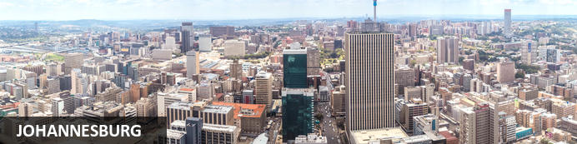
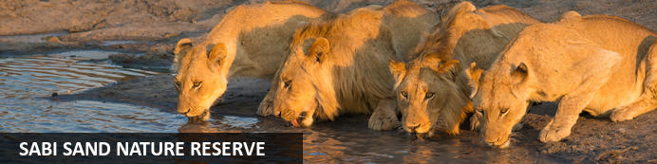
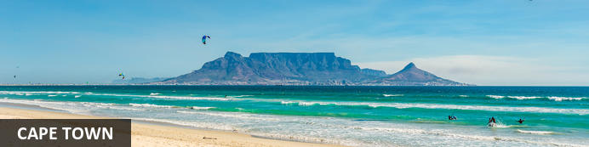
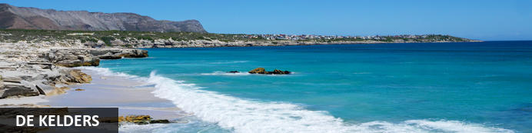

16-day Quintessential South African Journey
Johannesburg - Sabi Sand Nature Reserve - Gauteng - Cape Town - Franschhoek - Paarl - Stellenbosch - De Kelders
16 Days / 15 Nights

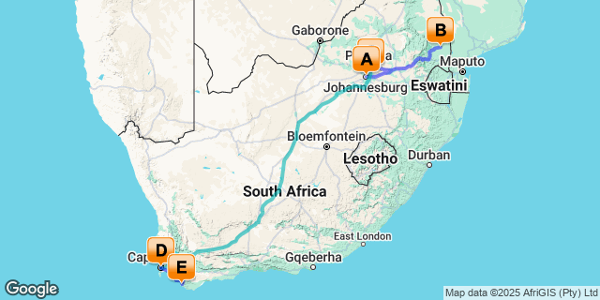

Click here to view your Digital Itinerary
Introduction

Accommodation | Destination | Basis | Duration
The Residence Johannesburg | Johannesburg | B&B | 1 Night
Sabi Sabi Bush Lodge | Sabi Sand Nature Reserve | FI | 3 Nights
Ivory Manor Boutique Hotel | Gauteng | B&B | 1 Night
Rovos Rail |  | FI | 3 Nights
One&Only Cape Town | Cape Town | B&B | 4 Nights
Grootbos Private Nature Reserve Forest Lodge | De Kelders | FB+ | 3 Nights

Key
B&B: Bed and Breakfast
FB+: Full Board Plus - Dinner, Bed, Breakfast, Lunch and Activities
FI: Fully Inclusive - Bed, All Meals, Fees and Activities
Price indication, based on 2 pax sharing for low season 2026:
ZAR 196 285.00 per person sharing
INCLUSIONS:
Accommodation as per itinerary
Tourism Levies
BB: Breakfast daily
Private transfers where mentioned in the itinerary with English speaking driver

Sabi Bush Lodge inclusions:
• Luxurious Accommodation
• All meals and beverages (including premium wines, spirits and liqueurs, but excluding French Champagne)
• Twice-daily game drives in open game-viewing vehicles, walking safaris (accompanied by experienced guides and trackers)
• Return transfers between Sabi Sabi Airstrip and the lodge
• Laundry service
• WiFi access where applicable

Rovos Rail inclusions:
All meals, high tea, drinks (alcoholic and non-alcoholic, excluding French champagne and caviar) and off train excursions.

Cape Town Inclusions:
Private tours in Cape Town with English speaking driver-guide
Private Half Day City Tour – includes Table Mountain Cableway Tickets
Private Full Day Cape Peninsula Tour – includes Cape of Good Hope and Boulders Beach
Private Full Day Cape Winelands Tour – includes 3x wine tastings/pairings

Grootbos Forest/Garden Lodge Inclusions:
- Luxury accommodation in freestanding suites
- Welcome drink served upon arrival
- Water, soft drinks, tea and coffee, minibar
- Fresh fruit daily in suite
- Breakfast with full English breakfast menu
- Light lunch
- 5-course dinner
- Horse riding for non- and experienced riders through the reserve (please note that the weight limit is 90kg/198lbs per person/ children under the age of 12 are only allowed on guided pony rides)
- Botanical Fynbos Hike on the Reserve
- Milkwood Forest Walk
- 4x4 Flower Safari
- Coastal drive with seasonal land-based whale watching (whale watching especially during July – December)
- Beach Picnics
- Ancient Klipgat Cave and Walker Bay Nature Reserve beach excursion
- Progressive Tourism Tour
- Mountain Biking on the Reserve
- Bird-watching; experience a great variety of bird species on the reserve
- Various maps of the reserve and the area for self-guided walks
- Children activities, i.e., treasure hunts through the forest and fynbos, pony rides and arts & crafts in the dedicated children playroom
- Transfers to/from all activities for included activities

EXCLUSIONS:
Block out dates, bank holidays, and minimum stay requirements
Additional meals and drinks
All Personal Items: Gratuity Beverages, Room Service, Telephone Calls etc.
Entrance fees not mentioned as included.
Travel insurance (please note that we strongly recommend you take out travel insurance to cover yourselves against any medical emergencies, cancellations, curtailment, etc.)
All Additional Flights
Visas and Taxes
Anything not mentioned as included
Porterage

Terms and Conditions: Prices are per person sharing, subject to change, currency fluctuations and availability. The exact amount will be confirmed at the time of booking. Advance purchase, peak or high season surcharges, block out periods and minimum stay conditions may apply. Price valid for dates as specified. Group rates are available on request. For standard Terms and Conditions please refer to https://www.southernafrica360.com/terms-conditions/ E&OE

Day 1: The Residence Johannesburg, Johannesburg

Johannesburg
Johannesburg is one of Africa’s largest and most vibrant cities. It is an economic powerhouse in Africa and the gateway to Southern Africa. This bustling city offers a wide range of activities, attractions and plenty to do in and around the city including nearby Pretoria. Downtown is a multi-cultural mixture of traditional medicine shops, Chinese restaurants, taxi ranks and ultra-modern skyscrapers. There are excellent museums, art galleries and organised tours of historical and political interest. The shopping is Southern Africa’s best and the many restaurants cater for all tastes. Soweto, a township steeped in history and a significant part of the Greater Johannesburg metropolitan area, is a popular tourist destination.

Day Itinerary
Arrival in Johannesburg
On arrival at OR Tambo International Airport in Johannesburg you will be met and transferred privately to your hotel.
Check-in at the hotel and spend the evening at leisure.

Overnight: The Residence Johannesburg View iBrochure
Welcome to The Residence Hotel. Set in the prestigious Houghton neighborhood of Johannesburg, The Residence Hotel is a boutique gem offering a unique blend of grandeur and warmth. Surrounded by leafy jacaranda-lined streets and historic landmarks, including the renowned Nelson Mandela Houghton Estate, the hotel is a haven of elegance. Thoughtfully designed interiors, hand-selected furnishings, and impeccable service create an atmosphere of refined comfort. Guests are embraced by an ambiance of sophistication and personalized attention, ensuring a stay that is both luxurious and deeply personal.
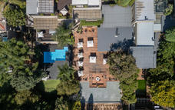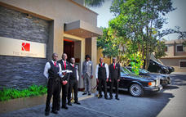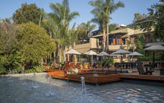

Basis
Bed and Breakfast

Day 2-5: Sabi Sabi Bush Lodge, Sabi Sand Nature Reserve

Sabi Sand Nature Reserve
Adjacent to the Kruger National Park, the Sabi Sand Nature Reserve is a private premier viewing destination. It was the first-ever private nature reserve established in South Africa. The landscape features 65 000 hectares of savannah-covered land interspersed with watering holes, dry river beds, Lowveld woodlands, and the perennial Sabi and Sand rivers. This spectacular reserve offers exceptional game viewing opportunities with frequent sightings of the renowned Big Five as well as cheetah, zebra, giraffe, and a variety of antelope. Visitors can enjoy excellent wildlife viewing, dining under the stars, guided bush walks and enjoying a stay in some of South Africa’s most luxurious safari lodges.

Day Itinerary
Sabi Sabi Bush Lodge Safari
This morning after breakfast you will be transferred back to the airport for your flight to the Kruger area (Sabi Sabi Airstrip). You will be met here and transferred through the game reserve to your lodge.
Your stay at Sabi Bush Lodge includes:
Luxurious Accommodation, All meals and beverages (including premium wines, spirits, and liqueurs, but excluding French Champagne) Twice-daily game drives in open game-viewing vehicles, walking safaris (accompanied by experienced guides and trackers).

Safaris
Two safaris per day - morning and afternoon/evening - 3 hours each with a morning and afternoon coffee/sundowner stop.
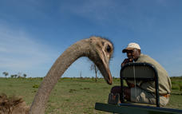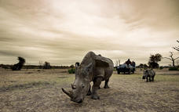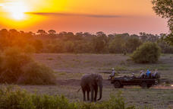

Walking safaris
A walking safari with your rangers is optional and takes place after breakfast, with your ranger.
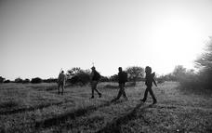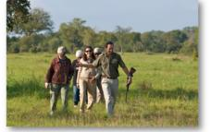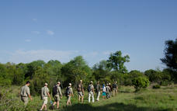

Amani Spa
We offer two full spas at the Amani Spas at Earth Lodge and Bush Lodge, however, guests from Little Bush Camp and Selati Camp are welcome to utilise these facilities. We can, on request, also offer in-suite massage treatments.
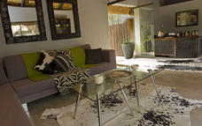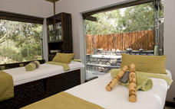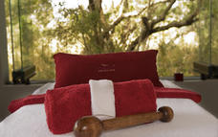

Overnight: Sabi Sabi Bush Lodge View iBrochure
Deep in the bushveld overlooking a waterhole and an open plain, lies a lodge that pulses to the rhythm of Africa’s heartbeat. Bush Lodge has earned a reputation of a “luxury home in the bush”, service excellence, personalised attention and offers an unrivalled 5-Star family safari.
Each stunning air-conditioned suite features sumptuous linens and fabrics, beautiful leather and wood furnishings, and an en-suite glass fronted bathroom with indoor and al-fresco shower leading onto a private patio.
Families with children of all ages are welcome and well-catered for at Bush Lodge and at the EleFun Centre where fun and games with trained caregivers are aimed at nurturing a deeper understanding and love for the surrounding bush.
There is ample space to relax, unwind and savour the tranquility of the bush. The two swimming pools and enormous covered viewing decks overhanging the Msuthlu riverbed are an invitation to cool off in the filtered water or sit in comfort while spotting game at the nearby pan. An exquisitely furnished lounge, atrium and intimate bar area are perfect meeting places for friends old and new.
As an extra indulgence, the Amani Spa at Bush Lodge offers the ultimate African spa experience.
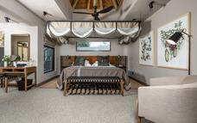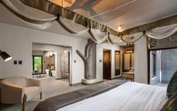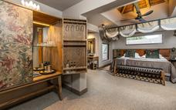

Basis
Fully Inclusive - Bed, All Meals, Fees and Activities
All Local Brands (Spirits, Wine and Beers) Included

Day 5: Ivory Manor Boutique Hotel, Gauteng

Day Itinerary
Sabi Sabi to Johannesburg, transfer to Pretoria for overnight
After your last morning game drive, breakfast and check out, you will be transferred to the Sabi Sabi Airstrip for your flight back to Johannesburg. Upon arrival at OR Tambo International Airport, you will be met in the arrival hall and will be transferred to Pretoria for overnight before your Rovos Rail journey.

Overnight: Ivory Manor Boutique Hotel
Ivory Manor Boutique Hotel, located in a lush suburb of Pretoria East just 30 minutes’ drive from OR Tambo, is a privately owned five-star hotel in the style of a stately manor house. With its fountains, grand entrance flanked by two sweeping staircases, plush public areas, and nine, individually decorated guestrooms with whimsical names such as Shades of Ivory and Moonstone, Ivory Manor Boutique Hotel strives to give discerning guests an exceptional experience from arrival to departure.
The sumptuous facilities and accommodation, surrounded by fairy-tale gardens, make Ivory Manor Boutique Hotel a popular destination for luxury escapes, romantic getaways and special occasions and events.
All suites have a Nespresso machine, a fully stocked mini bar, DStv, air-conditioning and spacious en-suite bathrooms with separate bath and shower.
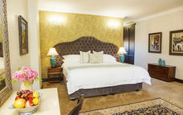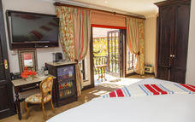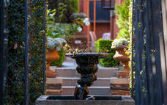

Basis
Bed and Breakfast

Day 6: Rovos Rail

Day Itinerary
Rovos Rail Day 1 Pretoria
Please check-in a minimum of one hour before departure. Should you wish to visit our museum or do a site tour at Rovos Rail Station, we suggest arriving two hours prior to departure.
10.00 Depart Rovos Rail Station, Pretoria. Travel across the goldfields of the Witwatersrand and the broad grassland plains of the Highveld. Guests may freshen up in their suites before joining fellow travellers in the lounge and observation cars.
13.00 Lunch is served in the dining cars.
16.30 Tea in the lounge and observation cars.
19.30 Dinner is served in the dining cars en route to Klerksdorp. Overnight on board. Dress: Formal

Overnight: Rovos Rail View iBrochure
Since its establishment in 1989, Rovos Rail has earned an international reputation for its truly world-class travel experiences. In a series of bespoke train journeys lasting from 48 hours to 15 nights, Rovos Rail links some of the continent’s greatest destinations with a variety of off-train excursions.
Step aboard the vintage wood-paneled coaches and sit back as some of the most varied scenery imaginable unfolds beyond the windows. With discreet and friendly service, top cuisine and a selection of South Africa’s finest wines, Rovos Rail harks back to a simpler, more elegant era encompassing the timeless grace and high romance of African exploration.
The beautifully rebuilt trains, which may be hauled by diesel or electric locomotives, carry a maximum of 72 passengers in 36 superbly appointed suites and are also available for charter, while the Events Train caters for up to 250 guests and is suitable for daytime journeys.
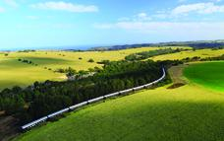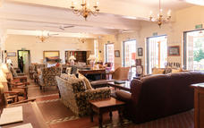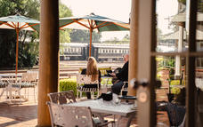

Basis
Fully Inclusive - Bed, All Meals, Fees and Activities
All Local Brands (Spirits, Wine and Beers) Included

Day 7: Rovos Rail

Day Itinerary
Rovos Rail Day 2: Kimberley
07.00 Breakfast is served in the dining cars until 10:00 en route to Kimberley.
13.00 Lunch is served in the dining cars.
Enjoy a tour of Kimberley’s Diamond Mine Museum and the Big Hole. Capital of the Northern Cape, Kimberley is well known for the discovery of diamonds that led to its establishment in 1871.
19.30 Dinner is served in the dining cars. Overnight on board. Dress: Formal

The Big Hole
The Big Hole, an awe-inspiring man-made crater is a gaping void, measuring 463 metres wide and 240 meters deep, was once the largest hand-dug excavation in the world, yielding an estimated 2,722 tons of diamonds between 1866 and 1914. The sheer scale of the hole, dug by over 50,000 laborers during its active years. Adjacent to the Big Hole lies the Kimberley Mine Museum, marking the initial discovery of diamond reserves in the country. A compelling aspect of the Big Hole in Kimberley is its transformation into the most visited tourist attraction in the area after the conclusion of mining operations.

Kimberley Big Hole Museum
The Kimberley Mine Museum offers a trip back in time to when diamonds were first found in South Africa in 1866, near Hopetown in the Northern Cape. Three years later the 83-carat 'Star of South Africa' was discovered in the same area, unleashing a frenzied diamond rush seldom seen before or since.

Basis
Fully Inclusive - Bed, All Meals, Fees and Activities
All Local Brands (Spirits, Wine and Beers) Included

Day 8: Rovos Rail

Day Itinerary
Rovos Rail Day 3: Matjiesfontein
07.00 Breakfast is served in the dining cars until 10:00. The train travels through the Karoo, a vast semi-desert region that was once an enormous inland sea. Over millions of years, volcanic matter was ground down and deposited as silt upon the seabed to form what geologists call the Karoo system.
13.00 Lunch is served in the dining cars. After lunch, there is a chance for guests to disembark the train at Whitehill Siding and walk the 5km into Matjiesfontein. A member of staff will accompany the group.
Disembark at Matjiesfontein for an opportunity to stroll through the historic village. Of special interest is the museum on the platform and a collection of historic cars and railway carriages to the right of the Lord Milner Hotel.
16.30 Tea in the lounge and observation cars.
About an hour after Matjiesfontein, the train arrives at the first of four tunnels on the pass. The first tunnel is 13.5km long so guests are to be careful when walking through the train and may wish to turn on necessary lights.
19.30 Dinner is served as the train climbs ±750m down the escarpment towards Worcester. Dress: Formal

Basis
Fully Inclusive - Bed, All Meals, Fees and Activities
All Local Brands (Spirits, Wine and Beers) Included

Day 9: One&Only Cape Town, Cape Town

Cape Town
Set at the confluence of the Indian and Atlantic oceans and backed by the iconic Table Mountain, the bustling city of Cape Town presents an alluring combination of drawcards. Incredible powdery white beaches, highly acclaimed wine routes, and astonishingly beautiful mountain trails surround a cosmopolitan hub. This diverse metropolis is filled with superb shops and restaurants, extraordinary heritage monuments, a multitude of entertainment venues, and a spectacular, chic waterfront harbour. Highlights include the Zeitz Museum of Contemporary African Art; Table Mountain's jaw-dropping views; Boulders Beach, where penguins might swim right up to you in the warm Indian ocean waters; the Kirstenbosch Botanical Gardens, where you can walk along a treetop canopy among incredible native flora or watch an open-air concert at the base of the mountain; Robben Island, where visitors can see the cell where Nelson Mandela was imprisoned for 18 years; and many more.

Day Itinerary
Rovos Rail Day 4: Cape Town
07.00 Breakfast is served in the dining cars until 09:30. The train travels through the Hex River Valley.
10.00 Arrive at journey’s end at Cape Town Station.

Overnight: One&Only Cape Town View iBrochure
An exceptional one-off resort, One&Only Cape Town is a captivating stage for escapism, where island-style relaxation meets a spirit for adventure. Situated on the vibrant Victoria & Alfred Waterfront, this chic urban resort places you in the heart of the Mother City, blending a rare sense of seclusion with the energy of South Africa’s most iconic sights right on your doorstep.
Let us curate your ultimate Cape Town adventure, from sunrise hikes to Lion’s Head and yoga sessions on top of Table Mountain, to immersive tasting and blending experiences at the region’s famed wine estates, and dining at the city’s finest restaurants within the resort.
Majestic Table Mountain makes her presence felt from every angle, framed by Vista Bar & Lounge’s soaring windows, and the expansive rooms, suites and penthouses of the Marina Rise. Across the waterways, the resort’s Island is a tranquil hideaway where lush gardens, a One&Only Spa serene water views, and a palm-shaded pool envelop you in an exclusive tropical oasis.
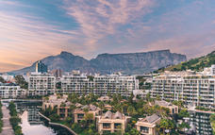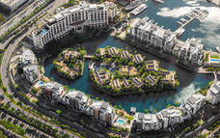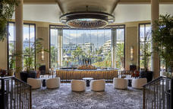

Basis
Bed and Breakfast

Day 10: One&Only Cape Town, Cape Town

Day Itinerary
Private Cape Town City Tour with Table Mountain
You will be met by your guide in your hotel reception area and taken on a Half Day Cape Town City Orientation Tour to learn about Cape Town’s rich history and vibrant cultures. The day starts with a cableway trip to the top of one of the World’s Natural Wonders – Table Mountain, also the city’s most iconic and recognisable landmark. Explore the walking trails at the top and take in the many different views point across the City Bowl, Table Bay, Atlantic Seaboard and Peninsula.
From Table Mountain your guide will take you back down into the city to visit the colourful Bo Kaap (Cape Malay Quarter), enjoy a walk through the Company Gardens and Greenmarket Square and an orientation drive taking in some of the important historical buildings (for example the Castle of Good Hope – South Africa’s oldest building), streets and features.
Highlights:
- Table Mountain and the aerial cableway (weather depending)
- Bo-Kaap – one of the city’s most Instagrammable spots thanks to its picturesque colourful houses and cobblestone streets
- The Company Gardens – a large public park lined with oak trees and surrounded by iconic historical buildings, museums and art galleries
- Vibrant Greenmarket Square market offering a wide range of African arts and crafts
- Orientation drive to see The Castle of Good Hope, City Hall, Grand Parade and Adderley Street with its many statues and historical buildings
The rest of the day will be at your own leisure, you can choose from a wide range of optional activities and excursions that Cape Town has to offer.
Optional Activities (at an additional cost):
- Visit to the lively V&A Waterfront where there are a variety of shops, markets, restaurants activities and attractions to enjoy
- City Tour by Bicycle or E-Bike
- Paragliding from Signal Hill or Lions Head
- Scenic helicopter flight
- Lions head guided hike (morning or sunset)
- Robben Island Excursion - with option of a private guided tour with Christo Brand as the guide (Nelson Mandela's prison guard who became his friend)
- A visit to Kirstenbosch National Botanical Gardens for a walk, including the Boomslang Treetop Canopy Walkway
- Cape Malay Cooking experience in the Bo Kaap
- If this day falls on a Saturday or Sunday a visit to a local Food Market (e.g. Oranjezicht City Farm or Neighbourgoods Market at the Old Biscuit Mill)
- Constantia Winelands Zip and Sip Trip (half day Ziplining and Wine Tasting in the Constantia Valley) or half day wine tour in the Constantia Valley

Table Mountain
Table Mountain is the most iconic landmark of South Africa. Aside from being the country’s most photographed attraction and the perfect place to take photos of the landscape of Cape Town, it is also home to about 2,200 species of plants and 1,470 floral species, many of which are endemic to the mountain. Animal species that can be spotted on the mountain include caracals, rock hyraxes and chacma baboons. The flat top peak of the mountain reaches 1,086 metres above sea level, but being so close to the sea and to the city, its features look more imposing.
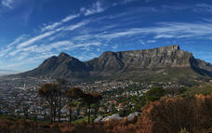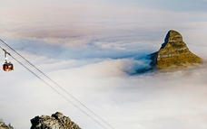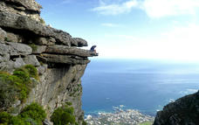

Basis
Bed and Breakfast

Day 11: One&Only Cape Town, Cape Town

Day Itinerary
Private Cape Peninsula Tour
You will be met by your guide in your hotel reception area and taken on a Full Day Cape Peninsula Tour. Cape Town is frequently acknowledged and awarded as being one of the world’s most beautiful places – this tour will show you why! Experience the spectacular natural splendour and abundance of life of the Cape Peninsula. With scenic views to take your breath away and photo opportunities galore this trip also takes you through a World Heritage Site – the Cape Floral Kingdom.
Travel along the Atlantic Seaboard to Hout Bay, passing magnificent beaches and the coastal suburbs of Clifton, Camps Bay and Llandudno. From the busy fishing harbour at Hout Bay you have the option of a boat trip to see the thousands of Cape Fur Seals living on a rocky outcrop. Browse for souvenirs at the Hout Bay Craft Market or take a walk on the beach and paddle your feet in the sea.
The tour continues over Chapman’s Peak, known as one of the most spectacular scenic drives in the world, all the way along the Peninsula to the southern tip at Cape Point. An invigorating walk takes you to the two lighthouses at the top and bottom of the headland, from where you will enjoy extraordinary views of the cliffs and the ocean below. Alternatively, you could take an optional short funicular ride to the top. Take a photo down at the most south-western point of the African continent at the Cape of Good Hope beach.
Lunch will be enjoyed at a seaside restaurant (excluded and for your own account) before we make our way along the False Bay coastline to the Naval village of Simon’s Town. We will visit the delightful African Penguins of Boulders Beach and then the drive takes us back via Cape Town’s coastal and southern suburbs.
Highlights:
- Drive along the Atlantic Sea Board passing the beautiful beaches of Clifton and Camps Bay
- Photo stop at Maidens Cove to take in the views of the Twelve Apostles mountain range, Camps Bay Beach and Lions Head
- Stop at Hout Bay Harbour – a busy fishing harbour
- Optional boat ride to Duiker Island to see the Cape Fur Seals
- Chapman’s Peak Drive – known as one of the World’s most beautiful drives
- Cape of Good Hope Nature Reserve and Cape Point – most South-Western point of Africa and the southern tip of the Cape Peninsula, spectacular scenery
- False Bay Coastal Road – look out for whales between June and November
- Visit the comical African Penguins at Boulders Beach
- Simon’s Town – home to South Africa’s Naval Base
- Picturesque drive past Kalk Bay and Muizenberg – see the famous colourful beach huts
- Kirstenbosch National Botanical Gardens – optional and time dependent
There are also a number of other exciting ways to explore the Cape Peninsula and fun activities which can be included as an alternative to the standard routing above:
Optional Activities (at additional cost):
- Snorkelling with Seals from Hout Bay
- Kayaking with Penguins from Simon's Town
- Waterbike Ocean Adventure from Simon's Town
- Surfing lesson in Muizenberg
- Explore the Peninsula or a section thereof via Side-car
- Self-drive the Peninsula in a classic convertible Cobra

Hout Bay
The originally small fishing village of Hout Bay is now a popular suburb of Cape Town. Over and above being a lovely family beach, it has many tourist attractions which include the World of Birds, a township tour to the vibrant Imizamo Yethu, arts and crafts, boat rides out to Seal Island and some great, casual restaurants where you can relax and enjoy the surroundings.
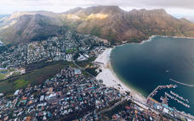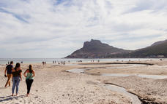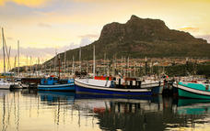

Chapman's Peak
Chapman’s Peak Drive winds its way between Noordhoek and Hout Bay. Situated on the Atlantic Coast, at the southwestern tip of South Africa, it is one of the most spectacular scenic drives in the world. The 9km route, with its 114 curves, skirts the rocky coastline of Chapman's Peak. The drive offers stunning 180-degree views with many areas along the route where visitors can stop and take in the scenery or sit down for a relaxing picnic.
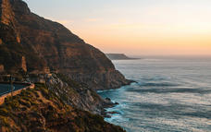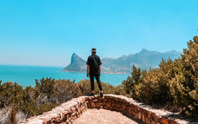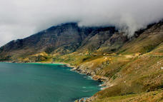

Cape of Good Hope
Cape of Good Hope is located near the southernmost tip of the African continent in South Africa. The cape is surrounded by beaches, coves, and cliffs, making it a popular location for sightseeing. The Cape of Good Hope is well known for its rich history. It was an important stop on the early trade routes between Europe and Asia. Today, the location is a popular tourist attraction. It provides visitors with stunning views and is also home to a variety of wildlife.

Cape Point
Cape Point is a spectacular sight, covered in endemic fynbos and home to breathtaking bays, beaches and rolling green hills and valleys, just 60km outside of Cape Town. Cape Point falls within the Cape Floral Region, a World Heritage Site. The Cape Floral Region is one of the richest areas for plants in the world – it is home to nearly 20% of Africa’s flora. Cape Point is open daily and is a must-see.
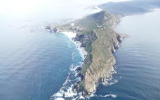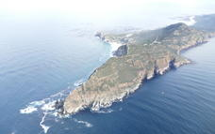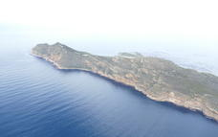

Boulders Beach
Boulders Beach is located in Cape Town, South Africa. It is a sheltered beach made up of inlets between granite boulders and crystal clear waters. The area is home to one of the largest breeding colonies of African penguins. Visitors can observe the penguins close up from elevated boardwalks while enjoying beautiful views. It is a popular location for swimming, snorkelling, and birdwatching.
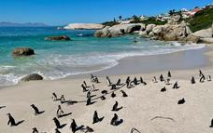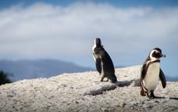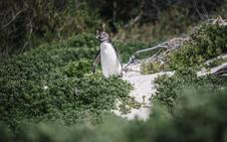

Basis
Bed and Breakfast

Day 12: One&Only Cape Town, Cape Town

Day Itinerary
Private Full Day Cape Winelands Tour
You will be met by your guide in your hotel reception area and taken on a Full Day Cape Winelands Tour. Situated only 45 minutes away from Cape Town, the Cape Winelands are surrounded by majestic mountains, beautiful vineyards and typical Cape Dutch style architecture. The Cape Winelands include the towns of Stellenbosch, Franschhoek and Paarl and are home to more than 150 wine estates and wine farms producing top-quality world-class wines. This region is also highly acclaimed for its many award-winning restaurants.
Head off to the heart of South Africa's wine industry, Stellenbosch, boasting great beauty and culture that is steeped in South African history. Walk down the canal-lined avenues, in the shade of giant oak trees and beautifully preserved historical buildings. With the sheer vastness of wine estates on offer, we are truly spoilt for choice when we enjoy our first wine tasting of the day.
Travel over the spectacular Helshoogte Pass to the town of Franschhoek, historically dating back to the 17th century when the French Huguenots arrived. Billed as the Gourmet Capital of South Africa, this charming town, in a most picturesque valley, retains a French Huguenot style. Enjoy a wine tasting before taking time to enjoy the fabled culinary skills of the Franschhoek chefs at one of the many restaurants (excluded and for your own account).
Onward to Paarl, one of the Cape’s first farming districts, for a final wine tasting. The town is set at the foot of the cluster of remarkable granite domes from which it takes its name. Return to the bustle of city life after an enthralling day in the countryside.
Highlights:
- Stellenbosch historical walking tour
- Visit Oom Samie se Winkel an interesting and old fashioned general dealer
- 3 Wine Tastings, with a chocolate OR cheese and wine pairing included, at various wine estates
- Franschhoek town walk
- The Huguenot Monument commemorating the Huguenot settlers of the 1680s who had a big impact on wine production in the region
- The Paarl wine area – overlooked by Paarl Rock (otherwise called Pearl Mountain), an enormous granite rock

Cape Winelands
Resting at the feet of the Boland Mountains in South Africa’s Western Cape Province, the Cape Winelands area is renowned for producing some of the world’s finest wines. The enthralling mountainous landscape boasts an impressive list of luxury wine farms, stretching across lush fertile valleys. Visitors can look forward to a variety of wonderful activities suited to all types of travellers. Explore a collection of historic little hamlets and towns dotting the countryside, sample a wide selection of world-class wine at historic Cape Dutch farmsteads and other wine estates; and make your way through a sublime network of hiking and biking trails. The culinary scene here is world-class and constantly improving; visitors who don’t drink alcohol will also enjoy discovering this destination as part of a ‘food tour’ - numerous superb restaurants are on offer.
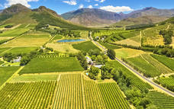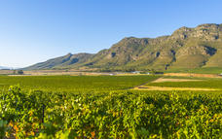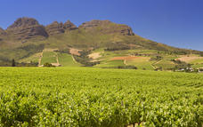

Paarl
Situated in the heart of the Cape Winelands, Paarl boasts an array of cultural and historical attractions and is surrounded by some spectacular nature reserves. Paarl was named after the huge granite dome of rock, which overlooks the town founded in 1690. The famous 11-kilometre-long Main Street features the Strooidak Church, Die Oude Pastorie Museum and the Patriot Building. The beautiful homestead of Labories in Main Street was bought by KWV. The KWV cellar complex is the largest in the world, covering an area of 22 hectares. The magnificent Cathedral Cellar, with its barrel-vaulted roof and large carved red wine vats is spectacular and depicts the history of the Cape’s wine industry. Visitors can enjoy a wide selection of activities including: wine tasting, scenic fynbos hikes, cycling, sampling local cuisine and much more.
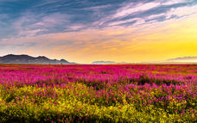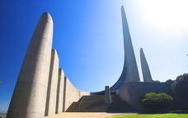

Franschhoek
Set just over an hour from Cape Town, within the inspiring landscapes of the Cape Winelands, Franschhoek is a heritage town and a world-renowned food and wine destination. Travellers could choose to focus their visit on any one aspect alone - nature, cuisine or culture - and find plenty to keep them busy. The estates here attract wine experts from around the globe with their Shiraz, Cabernet Sauvignon, and Cap Classique sparkling wine (among others). Five-star restaurants alongside the cellars are surrounded by the same jaw-dropping valley scenes that have brought artists and writers to the area for centuries. A superb literary festival takes place around May every year, and, combined with the town’s Cape Dutch manor houses, fascinating museums, and charming boutiques, makes Franschhoek a wonderful place to visit in winter. Summer provides endless hiking, cycling and other outdoor opportunities among the lush farmlands and mountains.
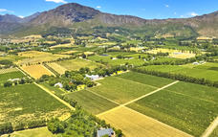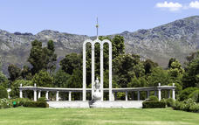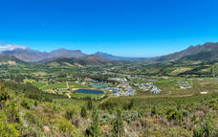

Stellenbosch
Just 45 minutes from Cape Town, Stellenbosch is an enticing Western Cape destination with an exciting culinary scene, photogenic historic buildings, and a youthful atmosphere. The beautiful university town is surrounded by mountains, vineyards, and nature reserves (Jonkershoek and Simonsberg), making it a charming base for wine tours, day trips and outdoor adventure. The town centre is characterised by both a “holiday feeling” - sublime art galleries, award-winning restaurants and alluring boutiques fringe leafy cobbled streets - and a sense of aliveness as students bustle between faculties. Architecture enthusiasts will enjoy the numerous Cape Dutch and Victorian buildings, while music lovers can look forward to world-class classical music concerts at the grand Music Conservatory. Two dreamy botanical gardens (with gorgeous tea rooms under the trees) add to the unique character of this special town.
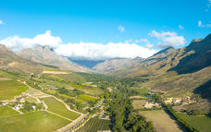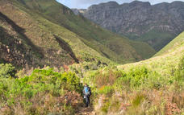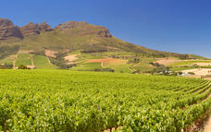

Basis
Bed and Breakfast

Day 13-16: Grootbos Private Nature Reserve Forest Lodge, De Kelders

De Kelders
De Kelders is a small town in Walker Bay, about two hours drive from Cape Town. Protected coves and inlets provide the ideal conditions for Southern Right Whales to mate and give birth, and, every year between July and November, these giant creatures can be spotted in the waters. A collection of caves offer much to explore; at Klipgat, some of the oldest human remains and stone artefacts have been found; while Drup Kelders presents a freshwater pool cave perfect for swimming and decorated by striking stalagmites and stalactites. The tranquil cove at Standford’s Bay is another perfect place to swim, surrounded by 150-year-old fig trees. Visitors can also enjoy hiking, angling, quad biking, and horse riding in the area, and the exquisite natural beauty of the Walker Bay Nature Reserve. Make sure to visit one of the local restaurants, too, which serve up wonderful fresh seafood.

Day Itinerary
Cape Town, transfer to Grootbos Private Nature Reserve
After breakfast and check out, you will be transferred to the Sabi Sabi Airstrip for your flight either via Johannesburg or Kruger Mpumalanga Airport to Cape Town.
Upon arrival at Cape Town International Airport, you will be met in the arrival hall by your local guide and will be transferred to Grootbos Forest or Garden Lodge.
Upon check-in at the lodge, a representative will discuss the daily program meals and activities.
Your stay at Grootbos Forest Lodge includes:
Luxury accommodation in freestanding suites
Welcome drink served upon arrival
Water, soft drinks, tea and coffee, minibar
Fresh fruit daily in-suite
Breakfast with a full English breakfast menu, Light lunch and 5-course dinner
Horse riding for non- and experienced riders through the reserve (please note that the weight limit is 90kg/198lbs per person/ children under the age of 12 are only allowed on guided pony rides)
Botanical Fynbos Hike on the Reserve
Milkwood Forest Walk
4x4 Flower Safari
Coastal drive with seasonal land-based whale watching (whale watching especially during July – December)
Beach Picnics
Ancient Klipgat Cave and Walker Bay Nature Reserve beach excursion
Progressive Tourism Tour
Mountain Biking on the Reserve
Bird-watching; Experience a great variety of bird species on the reserve
Various maps of the reserve and the area for self-guided walks
Transfers to/from all activities for included activities
Optional Activities (at an additional cost):
- Boat trip to Dyer Island combined with seasonal whale watching (July – December).
- Shark Cage Diving
- Scenic Flights
- Beach Horse Riding
- Fat Biking on the dunes
- Lady Stanford River Cruise
- Day trip to Cape Agulhas, the most southern tip of Africa
- Wine tasting at a wine estate

Optional
Boat-based Whale Watching (June - December)
Shark Cage Diving
Spa Treatments
Lady Stanford River Cruise
Fat Biking

Horse Riding on the Reserve
There’s something special about seeing a place on horseback. Take a slow trot as you appreciate the views or ride down the sweeping sand dunes, the fresh air filling your lungs and exhilaration pumping through your veins.
Horse riding at Grootbos is suitable for anyone, whether you’re a complete novice or a more experienced rider. Go for a relaxed ride through the fynbos or ride one of our special horses that are specifically trained for the beach. Our 22 horses at the Grootbos stables are well exercised and expertly trained, while all of our guides have years of experience in dealing with these noble animals.
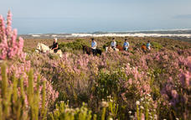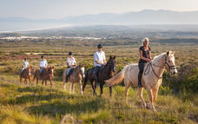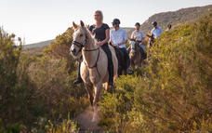

Land-based Whale Watching (June- December)
The Southern Right whales visit Walker Bay each year and being witness to them in action whilst they breach and blow is a very special experience to observe.These peaceful giants of the deep come to Walker Bay to mate and calf in the sanctuary of the Bay.. The Walker Bay rocky outcrops offer close viewing points from elevated positions.The Grootbos guides know all the best spots and this guided experience is an experience of a lifetime.
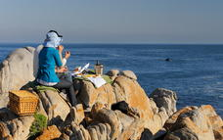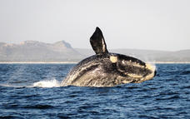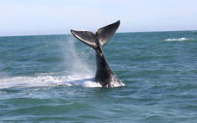

4x4 Flower Safari
Keep still, listen intently and you’ll be amazed at the things you learn on a botanical safari. With the richest temperate flora in the world and six completely new species never discovered by science before, your time at Grootbos will mean that you’ll never look at plants and flowers in quite the same way again.
The 800 recorded plant species in our 2500 hectares of pristine wilderness will bring the fascinating story of fynbos and forest to life as you touch, smell and see the natural miracles that surround you. Learn how a sunbird’s beak fits perfectly into a flower, why the honey our bees produce is completely unique and how important ravaging fires are for bringing forth new life.
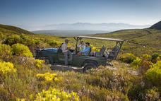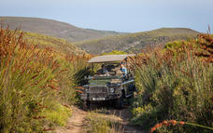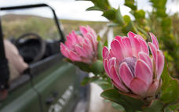

Beach Excursion
As a guest at Grootbos, there are so many different ways to enjoy the beach. You can take a long, relaxing walk on a solitary shore; laze in the sun on the luxurious white sand; or explore the unique coastal ecosystem while looking out for frolicking whales.
Our guides know exactly where to take you for the best swimming, tanning, walking, whale watching, angling and several other oceanic experiences on offer. We’ll transport you to and from the beach and provide you with a picnic lunch and all the beach accessories you need to enjoy your day in the sun.
Grootbos also offers guided beach tours where you can learn about the unique intertidal ecosystem; the abundant marine life; the coastal vegetation; and the geological forces that gave this coast its dramatic form.
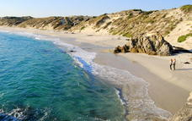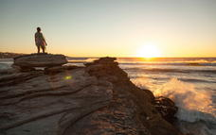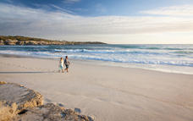

Bird Watching
A Bird's eyeview of Birding at Grootbos
Birding is akin to stargazing. On cloudless days, you see a myriad of these jewels flickering and floating in the sky, and once you know where and what to look for, you are transfixed by the ethereal pattern and order in their endless motion.
The Grootbos reserve and surrounding areas are a magnet to a wide variety of rare and endemic bird species feeding and breeding in the rich and diverse habitats. You know birding is not for the birds when you see how the Malachite Sunbird, with its bright green iridescent plumage, compete for attention with the flowering aloes and proteas. Grootbos is a birder friendly establishment endorsed by Birdlife SA. Our knowledgeable guides are geared to give bird watchers of all levels a winged overview of these magnificent creatures that enliven our skies and flora with their beauty and procreative activities.
Let's face it, the dazzling tapestry of fynbos wildflowers on Grootbos is not meant to attract tourists - the colourful displays of petals are nature's magic to lure birds and other pollinators to their nectar in exchange for spreading their pollen.
The beaks of the conspicuous endemic Orange-breasted Sunbird and the Southern Double-collared Sunbird are tailor-made for sipping the sweet stuff from the floral tubes of the various Erica species. You cannot miss the male Cape Sugarbird, with its ridiculously long tail (almost 70% of its total length), feeding on the nectar of Protea species. The impressive tail is solely a decorative testimony to manhood - the longer, the better! They whip their tails to attract females and ward off rivals.
In breeding season (September to April) Grootbos guests will encounter a magnitude of feisty and friendly fellows sticking together albeit they are not of the same feather. The diverse habitats - from fynbos, Milkwood and Afromontane forests to riverine scrub and mountain slopes - accommodate at least 120 different bird species, of which 30% are endemic or near endemic to Southern Africa. These include specials such as the Knysna Woodpecker, Cape Clapper-lark and the Southern Tchagra.
Flagship raptors of the area are the majestic Black Harrier, Jackal Buzzard, Forest Buzzard and African Fish-Eagle. The nearby agricultural fields are home to Blue Cranes, the Agulhas Long-billed Lark and the Denham’s Bustard.
Coastal Birding Tours
Grootbos, in partnership with Dyer Island Cruises, also takes guests on a "game viewing" cruise to Dyer Island, where endemics such as the African Black Oystercatcher, Hartlaub’s Gull, Crowned-, Cape- and Bank Cormorant, African Penguin as well as the Cape Gannet flourish. Pelagic species such as the Shy Albatross, Sooty Shearwater and Giant Petrels are also seen from time to time.
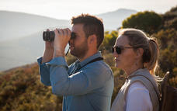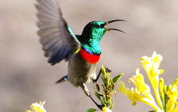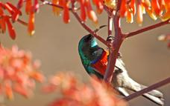

Klipgat Cave - an echo of early man
The Klipgat Cave outside De Kelders evokes vivid images of pre-historic times when modern man lived haply in symbiotic harmony with nature off the bounty of land and sea when the coastline was still kilometres away. This historical site in the Walker Bay was home to Middle Stone Age peoples some 70 000 to 80 000 years ago when large antelope such as black wildebeest and the extinct “blaauwbok” still abounded in the bay where dolphins, seals and whales now flourish.
Archaeological findings indicate that these primitive folks mainly lived off plants and smaller animals such as dune mole rats, tortoises and hares. They hunted steenbok and eland, while seabirds, shellfish and seals also formed an important part of their diet.
Dubbed Klipgat Cave (stone with a hole) after the remarkable window-like openings in the limestone rock formations that yield spectacular views of the bay and sea, the site is one of the most important cultural assets in the Western Cape. Innumerable stories of the perils and pleasures of yesteryear’s peoples unfold as layer upon layer of deposits reveal fascinating secrets of the tides, temperatures and living conditions of those early times. Later Stone Age pastoralists, believed to be the Khoekhoen/Khoikhoi, already kept sheep, and probably even cattle and dogs, in this area as early as 2 000 years ago.
They chiselled tools such as “needles” and “spatulas” out of bone to create ornaments, shell beads and pendants. Ostrich eggs were fashioned into water flasks, and tortoise shells served as bowls. These artefacts and bone samples are on display in the Cape Town Museum.
Unfortunately, the bulk of tell-tale everyday details of the loves and losses of man’s early ancestors is forever buried in the crags and crevices of this early home. Around 1713, a devastating smallpox epidemic claimed the lives of the entire local human population. The Klipgat Cave is of World Heritage significance and managed by Cape Nature Conservation.
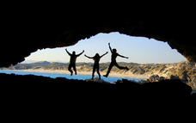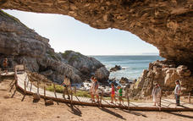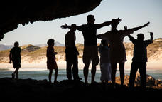

Walks and Hikes
Enjoy an entrancing stroll through our Milkwood forest or a more revitalising hike up our fynbos-clad mountains, as you begin to understand what makes Grootbos quite so special. From a sunbird sipping from a flower to an ocean vista that leaves you breathless, surprises await you around every corner.
Trails are all well marked and you can choose between self-guided walks or guided walks, to learn more about these fascinating and secretive eco-systems. Gaze into the petals of a King Protea, breathe in the blackcurrant scent of buchu or simply listen to the exquisite silence that surrounds you.
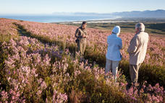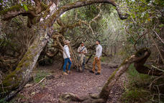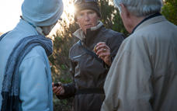

Living the Future Tour
Take a tour with heart as you discover how the entire Grootbos experience has been designed around benefitting the community and environment around you. Learn and connect as you witness how our various projects are changing lives and conserving this protected wilderness.
What is progressive tourism? It’s a term we coined to explain a new way of living that is at the heart of the entire Grootbos experience. It’s about every action we take benefitting someone else or having a positive impact on the environment.
From the freshly grown tomatoes you eat at lunch, to the recycled candles in your room, to the earrings you buy at the gift shop – we’re constantly seeking out new ways to create sustainable livelihoods for the people who call this unique area home.
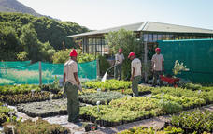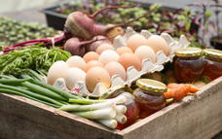

Hannarie Wenhold Botanical Art Gallery
Visit the home of the recently launched Grootbos Florilegium. The Hannarie Wenhold Botanical Art Gallery built on Grootbos Nature Reserve is an innovative space dedicated to the Florilegium’s fine botanical artworks and is a celebration of the hard work of all involved over the last five years.
The Grootbos Florilegium is the first contemporary African florilegium. Its intention is to celebrate and honor the Cape fynbos and the Cape Floral Kingdom in the southern Overberg, as a valuable botanical heritage of South Africa and as a record of the many rare, endemic and endangered plants of the region. The Florilegium is a global collaboration, featuring carefully selected botanical artists. 35 celebrated artists from South Africa, Zimbabwe, Reunion and the United Kingdom have lent their talent and expertise to the collaboration. A further 9 come from countries including the Netherlands, Brazil, the USA, Japan, Germany, South Korea and Italy.
The Grootbos Florilegium is representing nothing less than the best of the international botanical arts community.
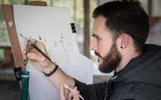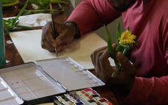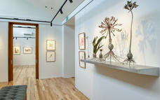

Boat-based Whale Watching (June - December)
Grootbos Nature Reserve has an exclusive boat trip, through Dyer Island Cruises, leaving every morning from Kleinbaai harbour. Besides seeing the amazing whales, this trip offers a complete experience of the Marine Big5, which includes the whales, dolphins, African Penguins, Cape Fur Seals and surface viewing of the Great White Shark. The boat comfortably accommodates 20 guests, has a toilet, upper decks, shelter from the sun as well as snacks and drinks provided onboard. The boat also has specialized guides, who can provide all the facts about the whales as well as other interesting information about the magnificent marine life. As these gentle giants are very curious, they often swim right up to the boat to get a better view of the boat and the guests. This trip takes about 2 hours and is a marine experience not to be missed!
Boat-based whale watching is not part of the standard Grootbos activities included in your rate.
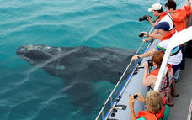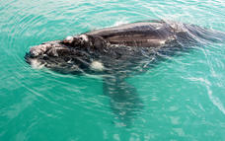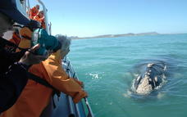

Shark Cage Diving
One of the most exciting experiences at Grootbos Private Nature Reserve is the Great White Shark cage diving. Gansbaai has the reputation for being the shark capital of the world. Divers and adventurers travel from all over the world to watch this magnificent creature in the waters around Dyer Island. Every day a number of boats leave Kleinbaai harbour to spend a few hours on the water to view the Great White Sharks from the boat or to go diving in a cage with these elegant and large predators. This is a once in a lifetime experience not to be missed!
Cage Diving (No diving experience required!)
This is truly one of the most adventurous activities on our planet, coming face to face with the Great White Shark. No diving experience is required, and all equipment is provided on board. When the sharks are around the boat, the divers get into the cage and the shark is lured to within meters from the cage. As the shark approaches, divers duck under water and marvel in amazement as this awe inspiring creature swims past the cage.
Surface Viewing
Grootbos guests have the choice to either enter the cage on the shark boat or view these magnificent creatures from the top deck of the boat. Surface Viewing is normally suitable for people wanting to see the shark from out of water and not necessarily come face to face with it inside the water. However, it is often commented that one gets a better view of the sharks from the top deck.
Shark Cage Diving is not part of the standard Grootbos activities included in your rate.
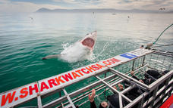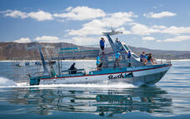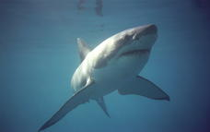

Spa Treatments
For those who just want to relax we offer an array of spa treatments. It is time to tip-toe into a slower world where the mind can drift away on the vapors of luxurious scents, such as sandalwood, arnica and buchu, while the body melts under the soothing touch of our fully qualified beauty therapist. Pampering takes place in the comfort of your own suite. For the tired body, a therapeutic full body massage is a definite must, leaving you in a state of absolute calmness. For the weary feet, reflexology, including a footbath, will most certainly do the trick. Manicures, pedicures, facials and a host of other treatments are available on request in our Bloom Beauty Salon or in the privacy of the suites at Grootbos.
Spa Treatments are not part of the standard Grootbos activities included in your rate.
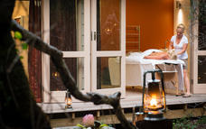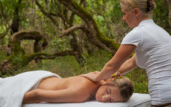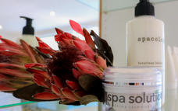

Lady Stanford River Cruise
Hop aboard the Lady Stanford river boat for a iconic and tranquil river cruise that winds its way gently along the picturesque Klein River, toward the Hermanus lagoon. Spend time on the open upper and lower decks of this modern eco-friendly river boat with its quiet, four-stroke boat engines, as you watch a kaleidoscope of natural colour go by.
No expense has been spared when it comes to comfort and luxury on board this vessel that most definitely stands out from the rest. A qualified skipper and experienced interactive guide, who intimately knows the river and all it has to offer, will ensure this journey is a memorable one. The Klein River features more than a hundred bird species which include majestic fish eagles, a flamboyance of pink flamingos and the ever spectacular, blue crane. Keep an eye out for otters, bontebok and horses grazing on the fertile river banks, as you make your way toward the lagoon. Lady Stanford runs daily trips for individual passengers as well as being available exclusively for private functions. The boat can comfortably accommodate 26 passengers.
The River Cruise is not part of the standard Grootbos activities included in your rate.
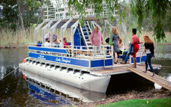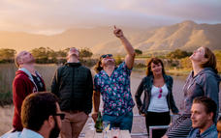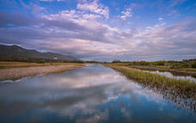

Fat Biking
This is the ultimate ride from Grootbos Nature Reserve down the mountain to the top of the Sand Dunes. The trail to the dunes is special, running on a narrow sandy horse trail through the Fynbos.
When reaching the dunes we will make our way up and across to reach a fantastic downhill section where we will pick up speed before reaching the top of our first vertical dune face. After a briefing on how to ride down the dune we down the face but for those just wanting an easy ride you can go around the side where it is an easy slope. The dune face may feel impossible and dangerous to do but the ride is in fact very controlled and the sand will slow the bike down.
What your mind tells you is impossible will in fact be very enjoyable and easy. I will be at the bottom of the dunes videoing your challenges so remember to smile. I will also teach you how to do slalom like a skiier on a snow ski slope. This is excellent fun on a bike and not too difficult to achieve. After the dunes we will pick up a 4x4 trail down to the beach. From there we will head back up to the car park but for those who are already tired I can bring the 4x4 down to the rocks so you do not have to ride up.
Fat Biking is not part of the standard Grootbos activities included in your rate.
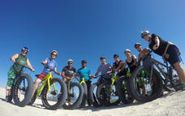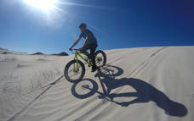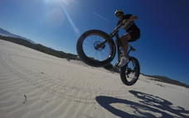

Overnight: Grootbos Private Nature Reserve Forest Lodge View iBrochure
Nestled in an ancient Milkwood forest in the peaceful Grootbos Private Nature Reserve, surrounded by rolling hills of fynbos and majestic mountains, The Forest Lodge features 16 freestanding luxury suites beneath an ancient forest canopy. Each of the suites is stylishly furnished with canopy beds, spacious en-suite bathrooms, separate lounges with cosy fireplaces and private wooden decks with spectacular panoramic views. The lodge features a variety of elegant dining venues, a bar, lounge, curio shop and conference centre. Spacious wooden decks and an infinity pool beckon you to relax and unwind. As the evening descends, cosy fireplaces and subtle lighting create a warm, romantic atmosphere for the perfect dining experience.
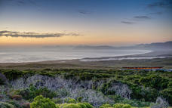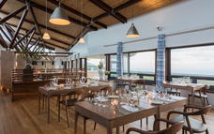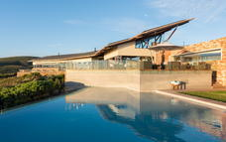

Basis
Full Board Plus - Dinner, Bed, Breakfast, Lunch and Activities

Day 16: End of Itinerary

Day Itinerary
Transfer from Grootbos to Cape Town International Airport
After your final morning activity (time permitting) and a hearty breakfast, you will be met by your local guide who will transfer you on private basis to Cape Town International Airport for your departure.

Basis
Bed and Breakfast

