

8-days Luxury Botswana & Victoria Falls Safari

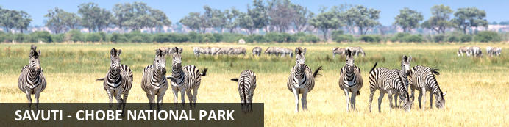
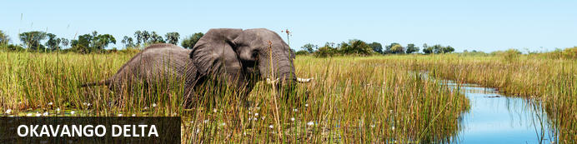
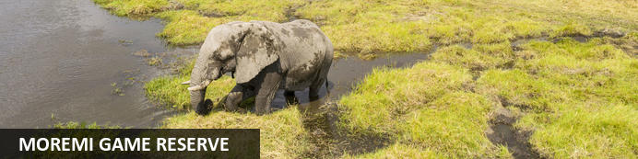
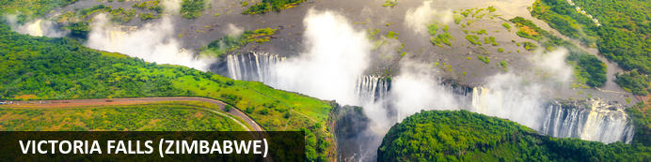

8-days Luxury Botswana & Victoria Falls
Savuti - Chobe National Park - Okavango Delta - Moremi Game Reserve - Victoria Falls (Zimbabwe)
8 Days / 7 Nights

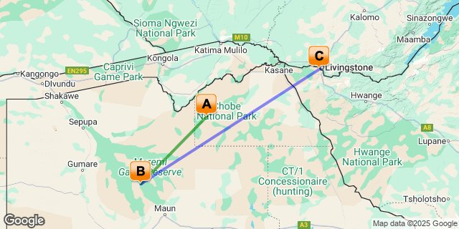

Click here to view your Digital Itinerary

Introduction
Embrace two thrillingly different safari experiences in Botswana. Savute Elephant Lodge sits beside the mysterious Savute Channel and Eagle Island Lodge is in the heart of the Okavango Delta. Each offers experienced guides, rich wildlife encounters and unique activities. Together they enchant even the most seasoned safari traveller. Finish your journey off with a three night stay on the banks of the Zambezi River at the stunning Victoria Falls River Lodge.
Dynamic Landscape: Elephants are, not surprisingly, the main attraction at Savute Elephant Lodge which boasts an exemplary eco-friendly design, luxurious spa and viewing hide. The majestic inhabitants are drawn to the mysterious Savute Channel, which flows and dries up seemingly at whim.
Ultimate Okavango: Eagle Island Lodge is a sustainably designed and built sanctuary that takes you magically close to the Delta's rich wildlife. Drift through the watery landscape on a mokoro canoe, spotting hippos and kingfishers, or fuel your adrenaline with a thrilling helicopter and horseback safari.
Nestled upstream from the iconic Victoria Falls, amidst lush indigenous bush on the Zimbabwean side of the mighty Zambezi River, Victoria Falls River Lodge awaits. As custodians of this pristine African wilderness, the lodge has been meticulously developed with a deep respect for the natural environment. Guests enjoy unparalleled proximity to the majestic Victoria Falls, where the distant spray can be glimpsed, yet revel in the serene and unspoilt surroundings, offering an authentic African safari experience with secluded privacy.

Accommodation | Destination | Basis | Duration
Savute Elephant Lodge, A Belmond Safari, Botswana | Savuti - Chobe National Park | FI | 2 Nights
Eagle Island Lodge, A Belmond Safari, Botswana | Okavango Delta | FI | 2 Nights
Victoria Falls River Lodge | Victoria Falls (Zimbabwe) | FI | 3 Nights

Key
B&B: Bed and Breakfast
FI: Fully Inclusive - Bed, All Meals, Fees and Activities
Nett Prices:
Low Season - 01 Jan - 31 Mar & 15 Nov - 23 Dec 2025
USD 6 150.00 per person sharing
USD 7 685.00 per single
USD 3 815.00 per child sharing aged 6-17 years
Shoulder Season - 01 Apr - 31 May & 01 Oct - 14 Nov 2024
USD 9 160.00 per person sharing
USD 12 385.00 per single
USD 5 345.00 per child sharing aged 6-17 years
High Season - 01 Jun - 30 Sep & 24-31 Dec 2024
USD 11 965.00 per person sharing
USD 16 570.00 per single
USD 6 770.00 per child sharing aged 6-17 years
Included:
7 nights Accommodation in twin/king-bedded rooms with air conditioning
Light aircraft flights from Maun, between the lodges, to Kasane and departure taxes
Botswana and Zimbabwe National park fees
Emergency medical evacuation insurance
All meals: breakfast, lunch, afternoon tea and dinner
All drinks, teas, coffees, soft drinks, house wines, local beer and a select list of spirits
Daily laundry services at Botswana Camps
2 game viewing activities per day at each lodge
Guided tour of the Victoria Falls (excluding Rainforest entrance fee, approximately USD 50 per person)
Excluded:
All international flights
VSOP Spirits, South African Reserve Wines and imported Champagne
Botswana departure tax where applicable
Optional/additional activities/Excursions/Entrance fees not mentioned as included
Visas
Travel Insurance
Gratuities
Personal Items
Anything not mentioned as included (please ask if unclear)

Terms and Conditions:
Prices are per person sharing, subject to change, currency fluctuations, and availability. The exact amount will be confirmed at the time of booking. Advance purchase, peak or high season surcharges, block-out periods and minimum stay conditions may apply. Price is valid for dates as specified. Group rates are available on request. For standard Terms and Conditions please refer to https://www.southernafrica360.com/terms-conditions/ E&OE

Day 1: Savute Elephant Lodge, A Belmond Safari, Botswana, Savuti - Chobe National Park

Savuti - Chobe National Park
Savuti, also known as Savute lies in the heart of Botswana’s beautiful Chobe National Park. This dynamic wilderness is a sweeping expanse of savannah brooded over by several rocky outcrops which guard a relic marsh and the dry channel that was once its lifeline. The Savute goes through wet and dry cycles, where wild dogs hunt in the dry river channel where crocodiles swam only twenty years ago. Visitors to this spectacular area can spot abundant wildlife including: a variety of birds, elephants, antelope, lion prides, black-backed jackal, bat-eared foxes, tsessebe, kudu, hyena, cheetah Cape buffalo herds, and thousands of migrating zebra and wildebeest.

Day Itinerary
Arrive in Maun, meet and greet at the airport and assistance to your scheduled charter flight to the Savute.
Check-in and orientation at the lodge, afternoon tea is served before your first afternoon activity.

Game Drives
It’s dark outside as a cup of steaming coffee and a freshly-baked pastry is brought to your tent. The first rays of sun are sneaking over the horizon as you set out with your guide. As the light intensifies, the scent of wild sage perfumes the air.
Early morning and late afternoon game drives take you out and among Africa’s largest populations of elephants. Big cats are on the prowl, from leopards to lions. Depending on the season you will also experience the great migrations such as zebra and antelope. Rare sightings might include the endangered wild dog, rock-climbing klipspringers and the elegant roan antelope.
Equally atmospheric and exciting are evening drives, as the shadows lengthen and the sky turns red. Animals and birds emerge from their siesta, and suddenly the bush is alive with sights and sounds.
Game viewing vehicles sit up to only 6 guests, allowing all on board to enjoy the wildlife from a window seat.
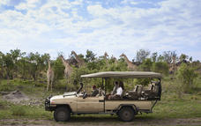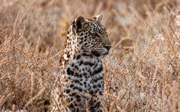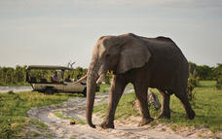

Lookout Hide
Head to our new viewing hide to enjoy a front-row seat of the action as elephants, hyenas and leopards gather at the watering hole for their daily drink.
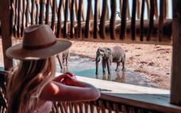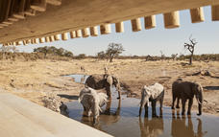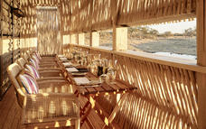

Bird Watching
It is a fascinating time to spot birds at Savute as the intermittent Savute Channel, dry for 30 years, is flowing past the camp again. With it has come a host of new bird species. Dry land birds such as bustards and secretary birds have suddenly been joined by more aquatic varieties. Simply sit out on your terrace and watch the show, especially at dawn and sunset, as they come to splash and drink right in front of your eyes.
Keen birders should also take note of the seasons. At certain times of year you may encounter annual migrations such as flocks of carmine bee-eaters on the move. Some ride on the backs of kori bustards—an amazing sight.
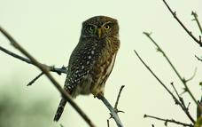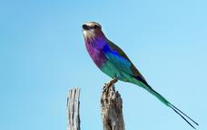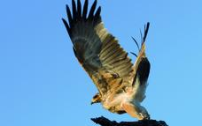

Bushmen Paintings and Baobab Trees
Out in the bush, where rocks rear up among stony hills you will find a collection of paintings that take your breath away. These works by Bushmen are thought to be more than 1,500 years old—beautiful images of elephant, giraffe, sable and eland antelope. Normally these types of painting might be found hidden in caves, but here, unusually, they are out in the wide, open landscape. No-one knows what materials the bushmen used, but the paint is thought to be a mixture of snake venom, blood and plant juices.
After viewing these paintings, continue to the amazing baobab grove—a cathedral-like cluster of 13 giant trees that rival the Bushmen’s paintings in age. Stand among these towering columns at sunset, as the evening light bathes them in a russet glow and wonder at this ancient land.
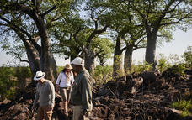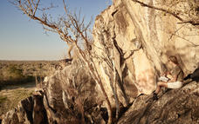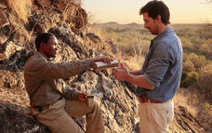

Star Gazing
The open skies around Belmond Savute Elephant Lodge make it the perfect place to experience the vast, dark dome of the African night sky. “A jewel box” is how one of our guides describes it, and certainly it is a wealth of riches from the Milky Way to Orion and Venus. Discover how Bushmen used the stars to locate the true south. And, using a powerful telescope, gaze on constellations that visitors from the northern hemisphere may never have seen before, including the Southern Cross.

The Boma
Gather around the campfire in this circular log hut and exchange your day’s adventures, much as local villagers do in similar buildings throughout Botswana. Flames flicker and lamps glow as drinks are served; a choir sings traditional songs and invites you to a buffet of African specialities.
Then take a comfortable seat and listen as camp guides recount tales of the bush. Musicians strike up traditional songs and the evening often ends with everyone on their feet, dancing to rhythms handed down through generations.
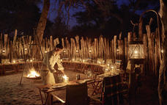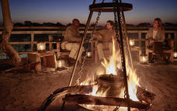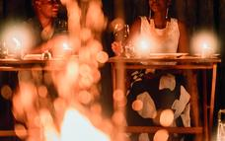

Dining at Savute Elephant Lodge
Enjoy a relaxed meal overlooking the stunning Savute channel in our raised restaurant.
Throughout the day you will have the opportunity to relax is in the quiet atmosphere of the lounge taking in the remote landscape.
Dinner (served around 8pm)
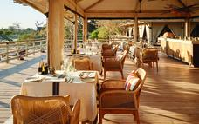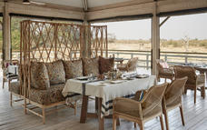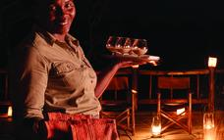

Spa Treatments
Discover our luxurious new spa tent, inspired by the elephants grazing on the nearby marula trees and traditional African healing practices. In a quiet spot at the edge of the lodge, surrounded by luxuriant bushveld, we invite you to put time on hold and lose yourself in a sense-soothing journey.

Overnight: Savute Elephant Lodge, A Belmond Safari, Botswana View iBrochure
An intimate immersion in safari culture at Savute Elephant Lodge, A Belmond Safari, Botswana.
Within our luxury eco-lodge in Chobe National Park, the untamed beauty of Botswana beckons
Thrilling safaris go hand in hand with tradition and local folklore in the heart of Chobe National Park. Let us take you on a journey along the unpredictable Savuti Channel, the land of Africa’s giants – the largest concentration of elephants in the world, prides of lions, Southern Africa’s largest zebra migration, San Bushman rock paintings, baobab groves and iconic local art complete this immersive experience. After exciting excursions, return home to our sustainable lodge where luxury accommodation and convivial dining provide the perfect stage to connect with the wilderness.
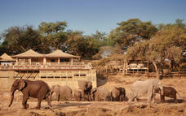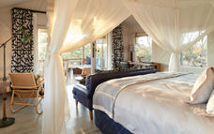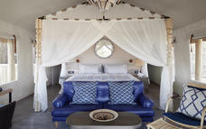

Basis
Fully Inclusive - Bed, All Meals, Fees and Activities
All Local Brands (Spirits, Wine and Beers) Included

Day 2: Savute Elephant Lodge, A Belmond Safari, Botswana, Savuti - Chobe National Park

Day Itinerary
Full day on safari with twice daily safari activities.

Basis
Fully Inclusive - Bed, All Meals, Fees and Activities
All Local Brands (Spirits, Wine and Beers) Included

Day 3: Eagle Island Lodge, A Belmond Safari, Botswana, Okavango Delta

Okavango Delta
Situated in the northwestern corner of Botswana, the Okavango Delta is a World Heritage Site as it is the largest inland delta in the world. The magnificent Okavango River sprawls out over the dry sands of the Kalahari Desert forming this flourishing waterlogged oasis featuring countless meandering waterways and crystal clear lagoons studded with water lilies, as well as fertile floodplains and reeded islands inhabited with abundant wildlife. The Okavango Delta stretches over an impressive15000 square kilometres. Visitors can enjoy a number of wonderful activities such as game viewing, fishing, bird watching or taking an authentic guided Mokoro excursion through this wetland paradise in a traditional dugout canoe. Commonly spotted animals include: lion, rhino, leopard, giraffe, hippos, elephants, crocodiles and countless species of bird.

Day Itinerary
Morning activity, check out and transfer to airstrip for scheduled charter flight to the Okavango Delta.
Check-in and orientation at the lodge, afternoon tea is served before your first afternoon activity.*
* Kindly note that water activities (Mokoro Canoe, Barge Cruise and Motorboat Safari) depend on water levels and are generally not offered during low season when water levels are too low.

Mokoro Canoe Safari
This traditional dugout canoe takes you gliding over shallow, clear waters past brilliant water lilies and papyrus grasses to areas inaccessible by boat.
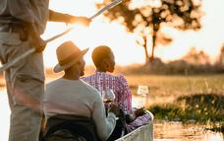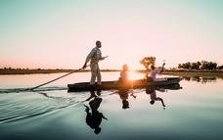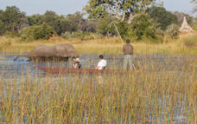

Walking Safari
On a walking safari through the Delta you are totally enveloped in nature. You spot amazing things close-up: an insect, animal tracks, big game droppings, swarming termite mounds. These small, unexpected aspects of life often make the biggest impression. If a game drive is like reading a book: a walking safari is like actually becoming a character in that book.
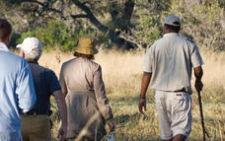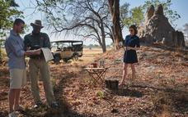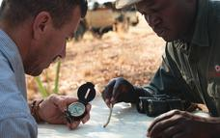

Bird Watching
Many people come to Belmond Eagle Island Lodge purely to experience its huge variety of birds. The 400 land and aquatic species drawn to the watery Okavango Delta make for unrivalled bird viewing.
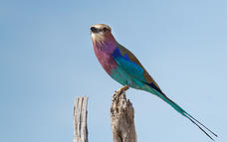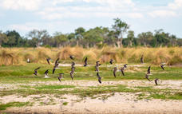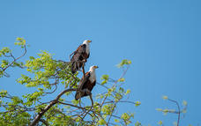

Motorboat Safari
Motorboat safaris up the Delta takes to closer to nature and far of areas not acceptable by foot or vehicle.
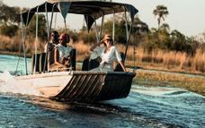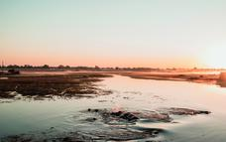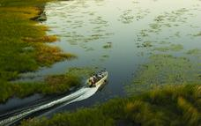

Barge Cruise
Take a slow gently cruise down the Delta for sundowners, you might just see a Fish Eagle taking flight or pods of hippos in the distance through an African sunset.
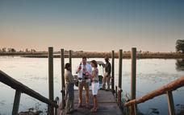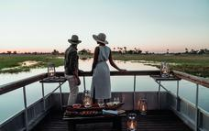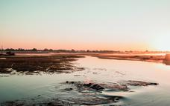

Game Drives
Morning and afternoon game drives are available in open land cruisers. Night game drives with spotlights and stargazing presentations are also available after dinner. As the lodge is located on a private concession, vehicles are allowed to drive before and after sunset, as well as off road.
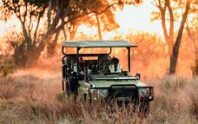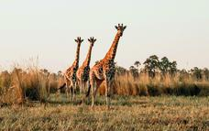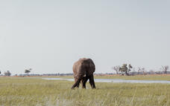

Dining at Belmond Eagle Island Lodge
Enjoy superb cuisine under cover or in the open air surrounded by nature and wildlife.
Our chefs will also happily prepare picnics for you to take on a game drive.
Game drives often start early. You will be woken with a light breakfast to enjoy in your tent before setting off on your drive.
Restaurant times:
Early breakfast (served around 6am)
Light snacks, tea and coffee on morning activity
Midday meal served between 10h30-13h30
Afternoon tea (served around 4pm)
Drinks and snacks on afternoon activity
Dinner (served around 8pm)

Fish Eagle Bar
There is no better place to experience the sunset over the Okavango Delta than from the Fish-Eagle Bar.
Open-air and covered bar and lounge areas with a dedicated viewing deck provide the best of both worlds - a complete view of the Delta coupled with the cool relaxation of this safari hideaway.
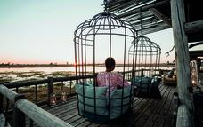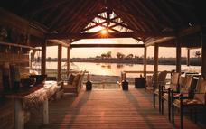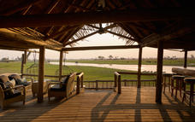

Helicopter Safaris
Here you experience the remoteness of the Okavango Delta and get a bird's eye view of the inaccessible lakes and islands.
Your pilot’s voice is coming through on the headset. “Look to the right where a herd of buffalos is crossing the river. We’re going down for a close-up view.” Next, you’re soaring up again. “We’re heading to a higher altitude. See the formation of the channels and the way in which the water and land mass has evolved over centuries.”
Helicopter flights over Botswana are one of life’s big adventures. Hunting has rarely been done from above and therefore animals are unperturbed by aircraft. Surprisingly, you may hover just a few feet over great herds of zebra as they continue to graze, completely unconcerned.
Even more exciting, you may be able to touch down on an island far away from human habitation and stand in a spot that has not been touched by the modern world. A speed boat may appear bearing coffee or a celebratory glass of sparkling wine: sip at leisure as you gaze on lush, riverine scenery—one of the world’s last great wildernesses.
(Additional rates apply)
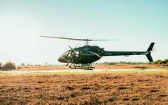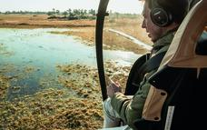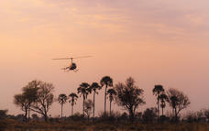

Village Life
Belmond Eagle Island Lodge is positioned close to Xaxaba village. On request you may visit the village and you may be invited into a private home to experience aspects of their way of life. This is no tourist attraction, but a community of people who have adapted ancient traditions to modern times.
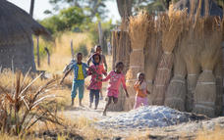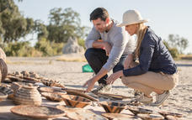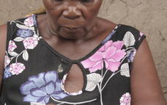

Private Dining
With incredible views cross the Okavango Delta and delicious food to match, the dining experience at Belmond Eagle Island Lodge is one to remember.
Choose an elegant candle-lit dinner on the private outdoor deck (additional rates apply).

Overnight: Eagle Island Lodge, A Belmond Safari, Botswana View iBrochure
Eagle Island Lodge, A Belmond Safari, Botswana, where luxury meets adventure.
Discover your explorer’s spirit at Eagle Island Lodge, in the very heart of the Okavango Delta
A stone's throw from our luxury safari lodge, limitless floodplains, pristine waterways and abundant food attract elephants, buffalo, antelope and other large herds, all followed closely by the attentive eye of the notorious African predators. Originally a crocodile hunting camp, we soon transformed into one of Botswana’s first photographic safari lodges, preserving the immense diversity of this now UNESCO World Heritage site. Eagle Island Lodge redefines the age-old art of safari living – set off on an intrepid safari journey on land, water and from the air.
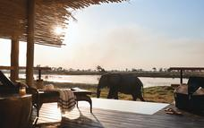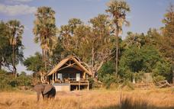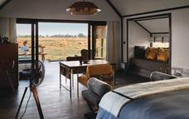

Basis
Fully Inclusive - Bed, All Meals, Fees and Activities
All Local Brands (Spirits, Wine and Beers) Included

Day 4: Eagle Island Lodge, A Belmond Safari, Botswana, Okavango Delta

Day Itinerary
Full day on safari with twice daily safari activities.

Basis
Fully Inclusive - Bed, All Meals, Fees and Activities
All Local Brands (Spirits, Wine and Beers) Included

Day 5: Victoria Falls River Lodge, Victoria Falls (Zimbabwe)

Victoria Falls (Zimbabwe)
Victoria Falls is one of the world’s most impressive waterfalls. It is set on the magnificent Zambezi River which creates the border between Zambia and Zimbabwe. These spectacular falls can be easily visited and viewed from the Zimbabwean side. Considered to be the world’s widest waterfalls, Victoria Falls measures an impressive 1708 metres in width. The small town of Victoria Falls, which lies adjacent to the waterfalls, serves as a great base from which to explore the many attractions this area of Zimbabwe has to offer. The surrounding area provides a wide range of adrenalin-filled activities for adventure lovers. Visitors can look forward to an array of wonderful activities including: scenic flights, micro lighting, white water rafting, bungee jumping, kayaking, and once-in-a-lifetime expeditions into the incredible Chobe National Park.

Day Itinerary
Transfer to airstrip for seat-in-charter flight to Kasane. Here you will be met and transferred across the Botswana border, into Zimbabwe to your luxury lodge located on the banks of the Zambezi River.
Lunch, check-in and orientation before your first afternoon activity.

Morning and Afternoon Game Drives
Join your Guide and head out in a game-viewer to explore the 150,000 acres that make up the Zambezi National Park.
Whether the opting to be the first to catch the ‘bush telegraphs’ early broadcast of the previous night’s events - or preferring to take a leisurely break, from an afternoon of game spotting, to enjoy the phenomenal sunset with sun-downers – a Victoria Falls River Lodge's safari experience promises to be memorable.
(Included in accommodation rate)
Kindly refer to the "Little Livingstone's Children's Activities" (Appendix C) for more information on activities specially developed for younger guests
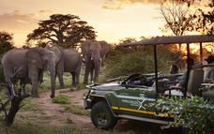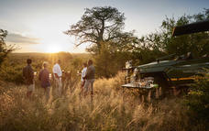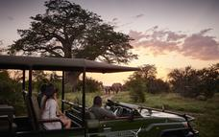

Sunrise and Sunset River Cruise
A relaxing voyage on one of the Victoria Falls River Lodge luxury river cruisers is arguably one of the best ways on earth to soak in the magnificence of the iconic Zambezi River and its surrounds.
Watch as the world awakes and the sun’s first rays skip and dance across the shimmering surface of the mighty Zambezi - a truly revitalising way to start any day!
Or, for the not-so-early-birds, sit back and let the gentle ebb and flow of the Zambezi lull and relax you.
Join in on Mother Nature’s Happiest Hour and sip on a sun-downer whilst viewing her creatures, big and small, coming to the water’s edge to lap at its liquid life.
(Included in accommodation rate)
Kindly refer to the "Little Livingstone's Children's Activities" (Appendix C) for more information on activities specially developed for younger guests
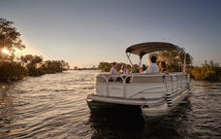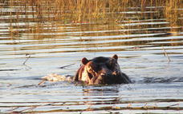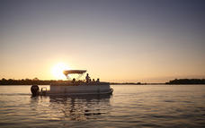

Guided Tour of the Falls
There is not much that can compare to the heady fragrance of drenched earth and sun-kissed Rainforest foliage, the intense power of the wall of water – its deafening rumble coursing through your veins – or letting the cooling and constant spray of “the Smoke that Thunders” saturate the senses…
Join your passionate and knowledgeable Victoria Falls River Lodge Guide on a truly unforgettable tour of Victoria Falls and experience this Natural Wonder of the Word first hand.
With intimate knowledge of the local fauna and flora and other points of historical interest, coupled with advice on the best viewing spots (and an extra pair of hands to help get that ‘full’ family photo!), our Guides will happily assist wherever possible to help ensure that the memories created at this World Heritage Site will last a lifetime.
(Included in accommodation rate)
Kindly refer to the "Little Livingstone's Children's Activities" (Appendix C) for more information on activities specially developed for younger guests
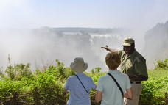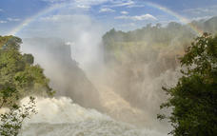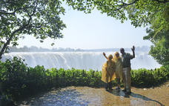

Bird Watching
Victoria Falls River Lodge and the Zambezi National Park are a bird watcher’s paradise.
In a comparatively small area around Victoria Falls, birding enthusiasts will be able to view a great diversity of birds within rain forest, riverine, gorge and savannah habitats.
Local species include Rock Pratincole, Schalow’s Turaco, African Finfoot, Half Collared Kingfisher, Thick Billed Weaver, African Skimmer, Pels Fishing Owl, Collared Palm Thrush and Western Banded Snake Eagle (to name but a few).
Guests at Victoria Falls River Lodge seldom have to travel too far from their private decks however as the lush foliage around the lodge offers ample opportunity to enjoy many of the spectacular array of bird life that Zimbabwe has to offer.
(Included in accommodation rate)
Kindly refer to the "Little Livingstone's Children's Activities" (Appendix C) for more information on activities specially developed for younger guests
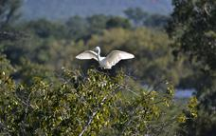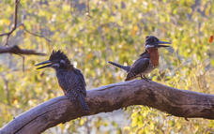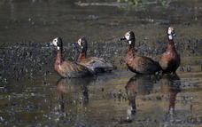

Children’s Activities (staying at Luxury Tented Suites)
Adventure options - for the younger generation
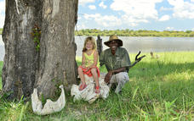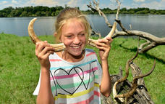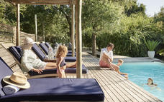

Guided Bush Walks
Experience the wonder of the African bush on foot and, when accompanied by an expert Guide, enjoy the thrilling opportunity to an up close and personal introduction to some of the Zambezi National Park's resident wildlife.
(Optional activity - available at an additional charge. Kindly refer to Appendix A for further details)
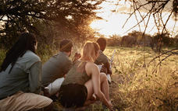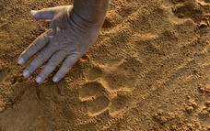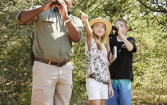

Fishing
The Upper Zambezi is home to a wide variety of fish species and Victoria Falls River Lodge offers half-day guided fishing trips leaving directly from the Lodge. Tiger fishing is a highlight and a unique experience on this iconic river.
Fishing from the jetty is also an option.
(Optional activity - available at an additional charge. Kindly refer to Appendix A for further details)
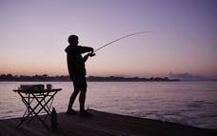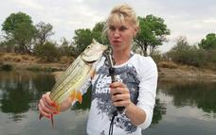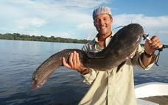

Overnight: Victoria Falls River Lodge View iBrochure
Victoria Falls River Lodge, on the banks of the mighty Zambezi River, boasts 2 Private Luxury Villas, 19 Luxury Tented Suites (each with a private deck and plunge pool), 6 secluded Island Treehouse Suites (sheltered amidst the treetops of the private Kandahar Island), spacious open-plan dining, lounge, and bar areas, an onsite fitness centre and the indulgent Toa Spa.
The first privately owned safari lodge to be built within the Zambezi National Park (Zimbabwe), the Lodge is ideally located for exploring Victoria Falls and combines the African Safari experience with one of the 7 Natural Wonders of the World – the iconic Victoria Falls – the spray of which can be seen in the distance!
Catering to a wide variety of tastes and preferences - from high-energy adventure enthusiasts to those seeking peace, relaxation, and tranquility; corporates; families; honeymooners; retirees embracing their golden years - Victoria Falls River Lodge offers something for everyone.
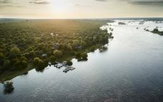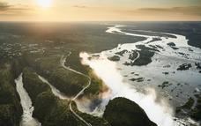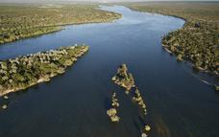

Basis
Fully Inclusive - Bed, All Meals, Fees and Activities
All Local Brands (Spirits, Wine and Beers) Included

Day 6: Victoria Falls River Lodge, Victoria Falls (Zimbabwe)

Day Itinerary
Full day to enjoy the wide range of activities on offer from the lodge and to relax and take in the unique setting.

Basis
Fully Inclusive - Bed, All Meals, Fees and Activities
All Local Brands (Spirits, Wine and Beers) Included

Day 7: Victoria Falls River Lodge, Victoria Falls (Zimbabwe)

Day Itinerary
Another full day to explore the Victoria Falls area.

Basis
Fully Inclusive - Bed, All Meals, Fees and Activities
All Local Brands (Spirits, Wine and Beers) Included

Day 8: End of Itinerary

Day Itinerary
After your final morning activity you will transfer to Victoria Falls Airport for your departure.

Basis
Bed and Breakfast

