

8-day Namibia Sand Dunes and Wildlife Safari

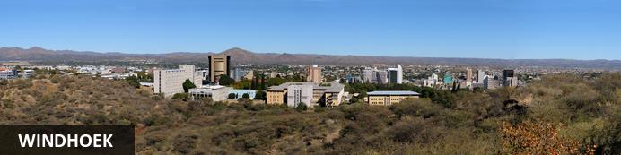
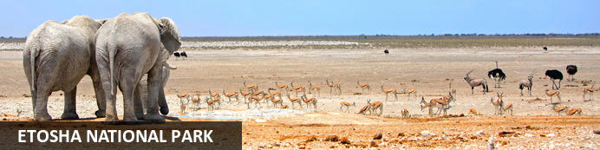
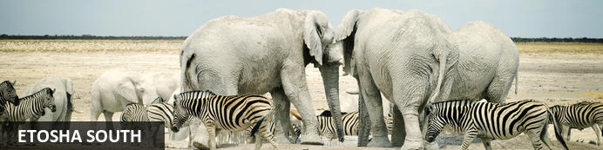
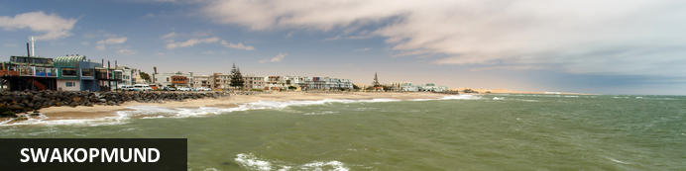
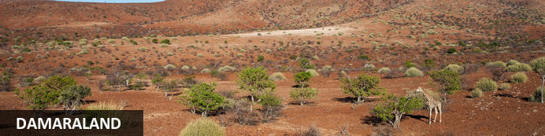
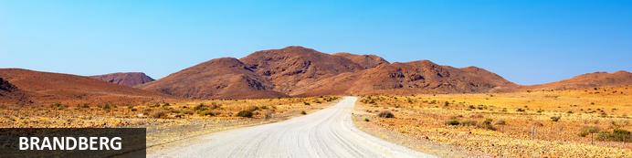
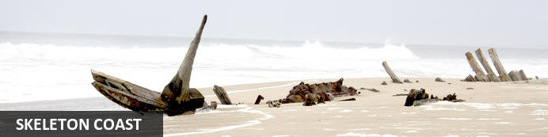
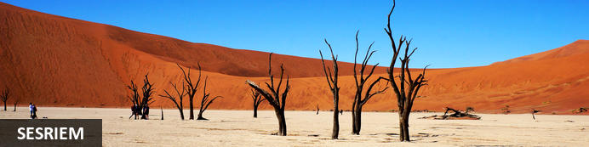
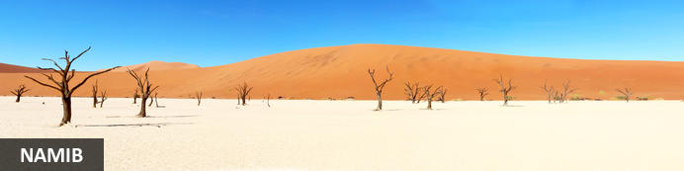
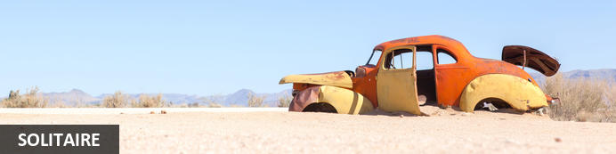
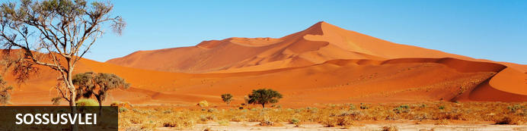
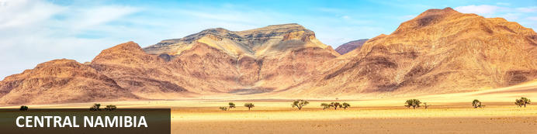

8-day Namibia Sand Dunes and Wildlife Safari
Windhoek - Etosha National Park - Etosha South - Swakopmund - Damaraland - Brandberg - Skeleton Coast - Sesriem - Namib - Solitaire - Sossusvlei - Central Namibia
8 Days / 7 Nights

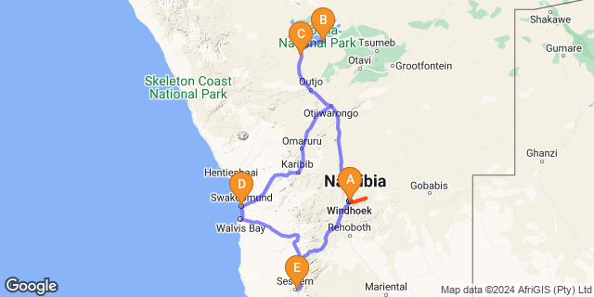

Click here to view your Digital Itinerary

Introduction
This fully accommodated and very comfortable safari might be short but it is action packed and stuffed full of many of Namibia’s Best of the Best. Game viewing in the world-renowned Etosha National Park, beautiful Damaraland and local tribes people. Namibia’s highest mountain – The Brandberg and the forbidding Skeleton Coast with a shipwreck to see and photograph.
We spend time in the historic coastal town of Swakopmund, sampling the delights of the excellent restaurants and having the chance to take part in wild activities in and around the coastal area.
The world’s highest sand dunes in the world’s oldest desert await and welcome us, and a scenic drive up over the Khomas Hochland and central plateau brings us back to Windhoek at the journey's end of one of our most popular safaris.
Departs weekly on Tuesdays and Thursdays, a pre-tour night in Windhoek is required on Monday/Wednesday night. Tour arrives back in Windhoek the following Sunday/Tuesday at approximately 15.30, therefore a post-tour night in Windhoek is also required unless a flight is booked after 19.00.

Start | Accommodation | Destination | Basis | Duration
Day 1 | Naankuse @ Utopia | Windhoek | B&B | 1 Night
Day 2 | Halali Resort | Etosha National Park | FB | 1 Night
Day 3 | Taleni Etosha Village | Etosha South | FB | 1 Night
Day 4 | Hotel Pension à la Mer | Swakopmund | B,B&L | 1 Night
Day 5 | Desert Camp | Sesriem | FB | 2 Nights
Day 7 | Naankuse @ Utopia | Windhoek | B&B | 1 Night

Key
B&B: Bed and Breakfast
B,B&L: Bed, Breakfast and Lunch
FB: Full Board - Dinner, Bed, Breakfast and Lunch

Nett Prices:
Valid until 31 March 2025
ZAR 26 980.00 per person sharing
Valid until 01 April – 31 December 2025
ZAR 32 865.00 per person sharing
*Single supplement only applicable to single travellers that request their own room, otherwise single travellers will be matched with another traveller of the same sex on a twin share basis. Single rooms subject to availability and only on request – please check with us first before confirming with your client.

Included
- 7 nights’ accommodation in twin share rooms with en-suite bathrooms
- 7 breakfasts, 5 lunches and 4 dinners
- Return shared airport transfers in Windhoek on arrival/departure
- Guided touring in an air-conditioned safari vehicle with pop-up roof
- National Park fees – Etosha and Sossusvlei
- Etosha Game Drives in touring vehicle
- Sossusvlei excursion (including 4x4 shuttle)

Excluded
- All flights, International & Domestic, reservations, taxes, fees etc.
- Additional meals and drinks
- All expenses of personal nature like tips, mineral water, laundry charges, telephone charges, etc.
- Any increase in services that may come into force prior to the commencement and any increase in the cost
- of land arrangements or airfare due to increase in fuel prices, fluctuations in foreign exchange rates etc
- Gratuities
- Any items not specifically mentioned in “included in price

Day 1: Naankuse @ Utopia, Windhoek

Day Itinerary
Monday/Wednesday - Arrival in Windhoek
On arrival in Windhoek you will be met at the airport and transferrred to your overnight accommodation in the city. Enjoy the rest of the day at your own leisure.

Windhoek
Situated in Central Namibia, the cosmopolitan city of Windhoek serves as the capital of the country. It is home to an international airport and a plethora of restaurants, shops, entertainment venues and accommodation options. The city is clean, safe and well-organised, with a colonial legacy that is reflected in its many German eateries and shops, and the widespread use of the German language. Windhoek has an interesting mix of historical architecture and modern buildings, many of which are worth a look, including the Alte Feste an old fort, the 1896 Christuskirche Christ Church, and the more contemporary Supreme Court.

Overnight: Naankuse @ Utopia View iBrochure
The modern N/a'ankusê@Utopia establishment has allied with the neighboring Pension Bougainvilla and offers serene rooms and luxurious suites situated amid beautiful, green lush gardens. The hotel is conveniently located in the tranquil suburb of Klein Windhoek.
Utopia combines business and leisure in a modest manner, simultaneously welcoming modern travelers and tourists in need of relaxation. Boasting 14 standard rooms, 7 luxurious suites and 1 executive suite, N/a'ankusê@Utopia creates an ideal hideaway.
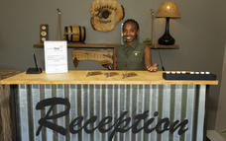

Basis
Bed and Breakfast

Day 2: Halali Resort, Etosha National Park

Day Itinerary
Tuesday/Thursday – Windhoek – Camp Inside Etosha National Park – 500 km
You will be collected from your accommodation within the Windhoek city limits at 07:15 and transferred to Headquarters for a short pre-departure meeting.
Heading north from Windhoek, we stop briefly at the small town of Otjiwarongo to gather some last-minute supplies before continuing on to Etosha and we enjoy a light lunch pack whilst “on the move”. We enter Etosha National Park and game drive our way to our overnight accommodation at Halali Camp. Etosha is huge, just over 22,000 square km and is home to 114 species of mammal, 350 species of bird, 110 species of reptile, uncountable numbers of insect and, somewhat bizarrely, one species of fish. There are good chances of spotting many of these different creatures as we tour through the park, stopping at the various waterholes along our way. All visitors must be in camp by sunset and we aim to arrive at our lodge before sunset and with time to settle into our rooms, with en-suite bathroom and tea/coffee facilities. Dinner at the camp restaurant is included.
The ‘game show’ in Etosha doesn’t stop when the sun goes down. All the Etosha camps have floodlit waterholes for extra game viewing opportunities. The Halali waterhole is located within walking distance from our accommodation. A visit, or two, is highly recommended this evening as we can expect many species to visit during the night and this waterhole is known to be very popular with elephants and the critically endangered black rhino.
Accommodation: Twin share, en-suite bathroom
Meals: Breakfast, Lunch, Dinner

Etosha National Park
Situated in northwestern Namibia, the Etosha National Park offers a premier game viewing experience. The park’s diverse vegetation ranges from dense bush to open plains attracting a variety of wildlife. Located in the heart of the park is the Etosha Pan - a shallow depression that covers an area of 5000 square kilometres. Dry and shimmering for most of the year, the pans fill up with water after seasonal rains, making it the perfect habitat for wildlife. In the dry season, the wildlife is attracted to the perennial springs and waterholes that makes for excellent game viewing. Visitors can look forward to world-class game viewing including a variety of large mammals such as lion, elephant, leopard, rhino, zebra, giraffe, a diversity of birdlife such as flamingos and pelicans.

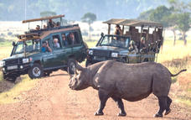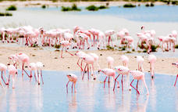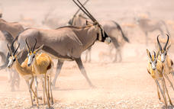

Overnight: Halali Resort
Strategically located halfway between Okaukuejo and Namutoni, Halali is situated at the base of a dolomite hill, amongst shady Mopane trees. A flood-lit waterhole viewed from an elevated vantage point provides exceptional wildlife viewing throughout the day and into the night. Accommodation is provided in family chalets, two and four bed bush chalets and double rooms, all converted with large sliding doors to the outside to allow visitors to experience and benefit from the peace and tranquillity of the natural surroundings. Other facilities include a restaurant, bar, shop, swimming pool, kiosk and camping facilities.
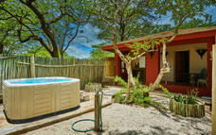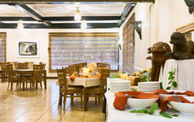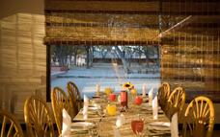

Basis
Full Board - Dinner, Bed, Breakfast and Lunch

Day 3: Taleni Etosha Village, Etosha South

Day Itinerary
Day 2: Wednesday/Friday – Etosha Park –Accommodation near Anderson gate – 70 km
We have the whole day to explore Etosha and we want to make the most of it. The park gates open at sunrise and we aim to be on our way just as the sun breaches the horizon. Early morning is usually a productive time for game viewing and first thing in the morning is a good time to catch big cats returning from the hunt.
We return to camp for breakfast and to load our vehicle before heading out into the park once again in search of big game. Etosha is a desert landscape and water is the most scarce natural resource.
There are however numerous waterholes here, both natural and man-made, and our game driving technique is to take in as many as of these possible. Here we hope that the game will come to us as the thirsty animals attend for a much needed drink.
On our way today we will stop to have a closer look at the Etosha Pan. The name Etosha translates as ‘great white space’ but this name does not do justice to the immensity of the pan. Over 4,700 square km of dazzling white mineral pan, so big that it can be seen from space.
We exit Etosha at the Anderson gate close to sunset and it is just a short drive to our accommodation in a comfortable spacious twin share room with modern en-suite bathroom facilities. An ideal space to sit back, relax and enjoy the beauty that surrounds you. Buffet dinner tonight at your accommodation.
Accommodation: Twin share, en-suite bathroom
Meals: Breakfast, Lunch, Dinner

Etosha South
Located just south of the boundary of Etosha National Park in northwestern Namibia, Etosha South makes up the southern region of this wild paradise. The area is comprised of a collection of world class private game reserves. The national park can be accessed via the southern entrance at Andersson’s Gate. Visitors can catch a glimpse of a variety of wildlife including: lion, giraffe, elephant, white and black rhino, and a multitude of plains game. Popular activities include: enjoying an open 4x4 safari with an expert guide, half day or full day drives with the option of a picnic lunch with wine on the full day game drive.

Etosha Pan
Aeons ago, Etosha Pan was the bed of a vast lake; today what remains is a glittering, silvery-green salt pan that stretches across roughly 5000 square kilometres. Etosha is protected by the Etosha Pan National Park surrounded by savannah plains and woodlands supporting large herds of elephants. When dry, the pan sustains little life except for the algae that gives it its distinctive colour, and migratory birds that use it as a pit stop, but with heavy rain it becomes a shallow lake where flamingos breed, pelicans wade and feed, and a variety of mammal species come to quench their thirst, including leopards, lions, white rhinos, hunting dogs and antelopes.
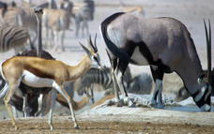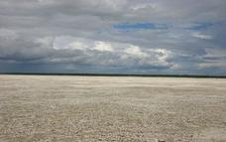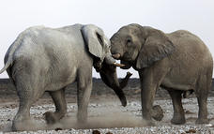

Overnight: Taleni Etosha Village View iBrochure
Affordable comfort at Etosha National Park near Okaukuejo
Situated only 2km from the Andersson entrance gate to Etosha National Park, Etosha Village uniquely combines affordability with comfort, style and exquisite cuisine.
The 45 individual suites offer a fully air-conditioned bedroom with an en-suite bathroom and a patio to enjoy the beauty that surrounds you. Two small children (under 12) can be accommodated with their parents on a fold-out sleeper couch in the unit.
Facilities include an open-plan bar with big screen television, 2 sparkling pools plus a kiddie pool, a restaurant serving delectable cuisine as well as a fully stocked utility and curio shop.
Explore Namibia’s animal kingdom with a morning or full day Guided Game Drives to Etosha National Park.
Enjoy the Walking Trails on our reserve where various small game can be spotted from the lookout decks and hides.
Sundowner Drives and Stargazing Sessions allow guests to experience the magic of our sunsets and famous star studded skies.
Let our team whisk you away to an enchanted venue in the Mopane Forest for a magnificent Boma Dinner Experience for your special function or private dinner.
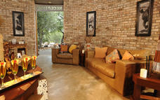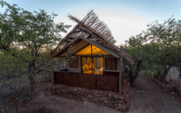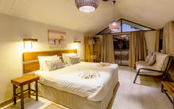

Basis
Full Board - Dinner, Bed, Breakfast and Lunch

Day 4: Hotel Pension à la Mer, Swakopmund

Day Itinerary
Day 3: Thursday/Saturday – Etosha – Accommodation Swakopmund – 510 km
After breakfast, we aim to be on the road by 07:30 today. We are heading for the Skeleton Coast and we are taking the scenic route. We first head south on the main road, passing the small town of Outjo, then onwards towards the west and picking up the gravel road as we travel through an area known as Damaraland.
Damaraland is famed for its scenery, mountains, open grasslands, tall koppies, (small hills), of round pink granite boulders, wide open spaces and big sky. We also have a chance to meet some of the locals as there are several places along our road today where we can find informal shops selling locally made, handcrafted souvenirs. Represented here we usually find ladies from the Himba, Herero and Damara tribes and most often they are wearing their traditional dress. Here we can interact with some of the colourful local characters who live in this harsh environment. Making a small purchase here is a good way to inject some cash directly into the local economy. We continue on through the beautiful landscape, making a stop for a light picnic lunch, under the shadow of Namibia’s highest mountain, the Brandberg. Rising up from the desert floor, this giant monolith is 2,573 m above sea level and is formed of pink tinged granite.
We continue our journey west and soon arrive at the coast and the chilly Atlantic Ocean. The whole coastline of Namibia is known as the Skeleton Coast and it is easy to see why this barren seaboard is so named with its forbidding mountains and barren beaches. The wind, the waves and the huge fog banks all conspire to push ships onto the beach. The countless mariners that, in olden times, found themselves shipwrecked here faced the stark prospect of no fresh water, no food, no rescue and a slow death by exposure. Their Shipmates who went down with their ship were thought to be the lucky ones.
Heading south on the coast road our next stop is a more recent shipwreck. 15 km south of the small town of Henties Bay a fishing trawler, The Zeila, was beached in 2008. She was an old vessel that had been sold for scrap and was under tow at the time. The cable snapped and, as so many vessels before her, she was caught in the swell and currents and ended up on the beach. She lays quite close to the shore and is well positioned for photos.
We complete the final leg of our journey into Swakopmund, we check into our accommodation, the centrally located and the town is easily explored on foot from our central location.Swakopmund was founded by Captain Kurt von François of the imperial colonial army of the German empire in 1892. (He also founded Windhoek in 1890). It is an interesting town to say the least, bounded to the north, the east and the south by the mighty sand dunes of the Namib Desert and to the west by the Atlantic Ocean. There are still many examples of colonial German architecture to be seen and the German language is still widely used.
Swakopmund boasts some truly excellent restaurants and again your guide will be able to help you with recommendations and bookings.
Accommodation: Twin share, en-suite bathroom
Meals: Breakfast, Lunch

Swakopmund
Set along Namibia's spectacularly scenic coast, the seaside town of Swakopmund is known for its wide-open avenues, colonial architecture, and its surrounding otherworldly desert terrain. Founded in 1892 as the main harbour for German South-West Africa, Swakopmund is often described as being more German than Germany. Now a seaside resort town, Swakopmund is the capital of the Skeleton Coast tourism area and has plenty to keep visitors happy. The quirky mix of German and Namibian influences, adventure options, laid-back atmosphere and cool sea breeze make it a very popular Namibian destination. Visitors can look forward to a number of exciting activities including: quad biking, horse riding, paragliding, fishing, sightseeing and fascinating desert tours.

Damaraland
This vast desert landscape is known as one of the most beautiful regions in Namibia. Huge, untamed and ruggedly beautiful, Damaraland is an exceptionally scenic landscape featuring open plains, ancient valleys and spectacular rock formations. The major attractions are the sacred Spitzkoppe, the Brandberg, Twyfelfontein, Vingerklip and the otherworldly Petrified Forest. Visitors can take in the dramatic vistas, catch a glimpse of the rare desert-adapted elephant, and enjoy spectacular stargazing in crystal-clear night skies from one of the many safari camps dotting Damaraland. Other popular activities include: guided drives, nature walks and visiting the local communities. Don’t miss the opportunity to view Damaraland's world-famous ancient rock art.
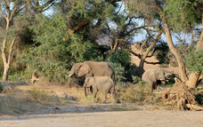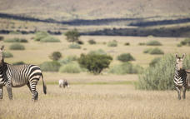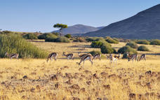

Brandberg
Situated in northwestern Namibia, the Brandberg, meaning 'Fire Mountain', Massif is Namibia’s highest peak, at its zenith, the Königstein (King’s Stone), standing at a whopping 2573 metres above sea level. Named for the vivid shade of orange it sometimes turns at sunset, this is undoubtedly the main highlight of the region. The Brandberg has been sacred to the San people for centuries. The Tsisab Ravine at its base is permeated with over 45 000 ancient San rock paintings, including the famous ‘White Lady’. Visitors flock here to view this unique bushman painting, said to be over 2000 years old. Other popular drawcards include its untouched natural beauty and its free-roaming wildlife such as mountain zebra, kudu, springbok, and desert elephant.
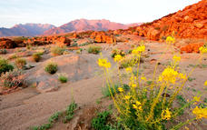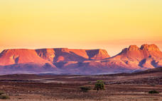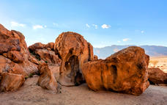

Skeleton Coast
Stretching from the Swakop River to southern Angola, Namibia’s Skeleton Coast is known as the 'Land God Made in Anger'. Thousands of miles of sandy desert dotted with shipwrecks meet with the cold waters of the Atlantic, where ocean fog creeps over the shoreline. Somehow, an amazing array of wildlife and flora manages to survive in this harsh but beautiful environment. Animals living here include seabird colonies, Cape fur seals, zebras, gemsbok, desert-adapted elephants, lions, and many more. Surfing enthusiasts are drawn to the powerful crashing waves, and photographers flock from around the globe to snapshot the eerie shipwreck graveyards and breathtaking coastline.
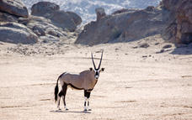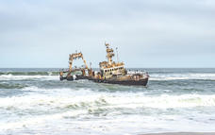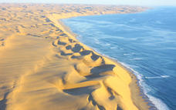

Overnight: Hotel Pension à la Mer
Overlooking the ocean, Hotel Pension à la Mer offers accommodation located in the heart of Swakopmund, Namibia. The property features 46 en-suite rooms equipped with safety deposit boxes, heating, tea/coffee-making facilities and free Wi-Fi. Guests can look forward to an inclusive international buffet breakfast on-site each morning. Additional hotel amenities include a bar, a snack bar, a sun terrace, a mini-market and a gift shop. Local activities include dolphin cruises, scenic flights, hot air balloon rides, fishing and quadbike tours.
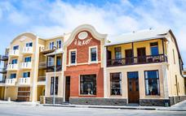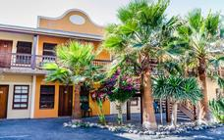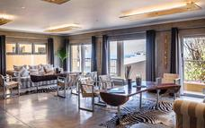

Basis
Bed, Breakfast and Lunch

Day 5: Desert Camp, Sesriem

Day Itinerary
Friday/Sunday – Swakopmund - Accommodation, near Sesriem – 350 km
We have the option to have a more leisurely start this morning as we are only leaving Swakopmund in the middle morning.
If you choose not to have a lie in then Swakopmund offers many opportunities to keep us busy during our morning here. The town centre is small and easily explored on foot but there are also many extra, optional activities available.For those with a love of adrenaline quad biking and sand boarding is very popular if you fancy careering down the slip face of a sand dune at 60 km per hour.Our guide will discuss all the options with you in advance and will be able to facilitate any bookings that we would like to make.
Departing Swakopmund 11h30 we head east into the desert. We first cross the Namib gravel plains, large areas of flat and seemingly barren terrain broken up by huge mountain inselbergs. We have two mountain passes to traverse this afternoon, first is the mighty Kuiseb Pass and we follow the road from the top of the mountains, dropping steeply down into the canyon carved over eons by the Kuiseb River on its way to debouch into the ocean at the port town of Walvis Bay.
We climb up from the banks of the river and over the pass, travelling through the mountain peaks and on to the second, smaller canyon of the Gaub River, a tributary of the Kuiseb. We emerge from the mountains onto a flat road and almost immediately we cross the Tropic of Capricorn at 23.5 south degrees. There is a signpost at this auspicious spot and we stop along the road for photos.
From here we continue on through the desert landscape to the tiny town of Solitaire where we can stretch our legs and sample the apple pie that has made this homestead famous.Onwards again to our accommodation for the next two nights.
Overnight is in twin rooms with en-suite bathroom facilities.There is a pool and bar availableas well as a buffet dinner tonight.
Accommodation: Twin share, en-suite bathroom
Meals: Breakfast, Lunch, Dinner

Sesriem
As there is no accommodation at Sossusvlei, visitors to this desert wilderness are likely to end up staying at Sesriem, 65 kilometres away, where camps and lodges serve as a base from which to explore the dunes. Sesriem Canyon, a deep chasm carved through the rocks by water, is a striking natural feature of the area that is best explored on foot. Stony walls rise up sharply on both sides of the canyon, while birds roost in its crags and lizards dart along the ledges. The canyon’s name was coined when early settlers used it as a water source, using six lengths of leather (‘ses riem – six thongs) tied together to lower buckets into the water at the base of canyon.)

Namib
The Namib Desert is the world’s oldest desert, and although it stretches along the entire length of Namibia’s coastline into southern Angola and even the northern Cape Province of South Africa, the Namib commonly refers to the vast sea of sand extending from Luderitz to Swakopmund. This vast expanse of breathtakingly beautiful sandy desert features remarkably varied scenery including, the massive red dunes of the world-renowned Sossusvlei, the moonscapes of the Namib-Naukluft Park, the stark beauty of the Atlantic Coast and a diversity of fauna and flora. This windswept, arid, ancient landscape is teeming with desert-adapted wildlife such as endemic chameleons, brown hyenas, gemsbok, jackals and seals along the coastline and a variety plantlife including the famous welwitschia plant, a unique living fossil. Other highlights of the Namib include: Fish River Canyon, Kolmanskop ghost town, Luderitz, Cape Cross seal colony and the Skeleton Coast.
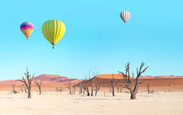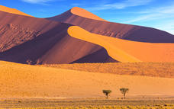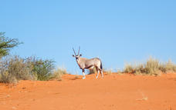

Kuiseb Pass
Kuiseb Pass takes you through the Kuiseb Canyon, the watercourse of which only flows occasionally but often enough to halt the advance of the red sands of the Namib.
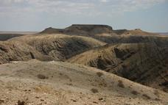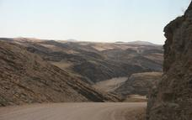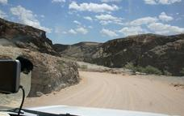

Solitaire
Situated in the Khomas region of Central Namibia, the desert town of Solitaire serves as an oasis in the Namib Desert. The town provides an important stop on the way to the ancient dunes of Sossusvlei, allowing travellers to stock up on essentials as they make their way further into the wilderness. Solitaire also has a small bar and is renowned for its famous apple pie - said to be the best in the country. Enjoy a scenic sundowner with views of the spectacular Namib desert, hike and bike through the unspoilt natural surroundings, or visit the wonderful local Cheetah Sanctuary.
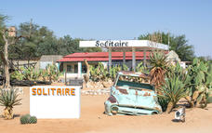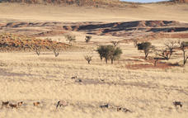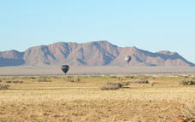

Overnight: Desert Camp View iBrochure
Self-catering at its Best amidst unparalleled Desert Beauty...
Desert Camp is situated just 5 km from the entrance gate to Sossusvlei and Sesriem Canyon in the Namib Nauklauft Park. Nestled under centuries old camel thorn trees, Desert Camp offers unsurpassed views over the Desert landscapes and surrounding mountains - An absolute must for the nature lover and photographer!
The 28 affordable self-catering accommodation units are equipped with an en-suite bathroom, shaded veranda with a fitted kitchenette, barbeque, power points and an adjacent parking area. Each air-conditioned room features twin beds and a fold-out sleeper couch to accommodate 2 small children (under 12) free of charge when sharing with 2 full paying adults. Utility boxes with most utensils needed are available at reception and fresh food supplies can be ordered daily.
Facilities at the main building include a fully stocked and serviced bar with big screen television, a sparkling swimming pool and 2 communal bomas with cooking and wash up facilities which are perfect for groups travelling together.
Meals can be enjoyed at the nearby Sossusvlei Lodge restaurant and their Adventure Centre offers a range of exciting Desert activities to explore the area.
A fully stocked shop, fuel and an Internet café is available at the Sossus Oasis Service Station.
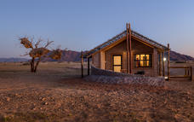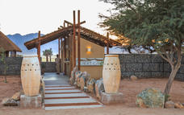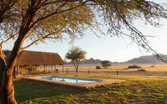

Basis
Full Board - Dinner, Bed, Breakfast and Lunch

Day 6: Desert Camp, Sesriem

Day Itinerary
Saturday/Monday - Sossusvlei – 220 km
Getting into the dune area as early as possible this morning is the aim and that means a pre-dawn start and a very early breakfast. As we are staying outside of the national park we will enter the dune area as soon as the gate opens at sunrise.
The best time to photograph the dunes is around sunrise and sunset. This is when you can see towering sand dunes illuminated a glowing orange, apricot red on one side and swathed in shadow on the other. The depth of field is amazing at this time of day. From Sesriem we cover the 60 km into the dunes quickly and arrive at the 2x4 car park where all 2 wheel drive vehicles have to stop. From here we enter the ancient Tsauchab River-bed for the last 5km leg to Sossusvlei itself.
The Tsauchab River is ephemeral, it only flows seasonally, when there is enough rain, and for the most part the river-bed is dry. Eons ago, during these rare floods the Tsauchab sometimes received enough water to flow all the way to the Atlantic Ocean. However, as the millennia passed and the dune fields began to form, (around five million years ago), wind -blown sand invaded the river-beds. The rivers became more and more constricted by sand until eventually the occasional floods could not break through the sand barriers that had been erected by the wind. The valley we drove along this morning to get here is kept free of sand by the Tsauchab but Sossusvlei is now permanently waters end.
Sossusvlei does still sometimes flood, (perhaps once in a decade). After good rains in the Naukluft Mountains where the river rises Sossusvlei can become inundated, and the lake that this creates can last for many months, but no longer can the river find its original path to the Atlantic. There is a 4x4 shuttle service that will transport us through the sandy terrain of the river-bed.
We will visit Dead Vlei, an ancient pan completely surrounded by dunes, that is strikingly populated with dead, skeletal camelthorn trees. These trees have been a feature on this landscape for over 1000 years. Sossusvlei is almost surrounded by dunes, just one narrow path kept open by the Tsauchab River. We have time to explore the area on foot and to climb one of the highest dunes in the world, some towering 300 m above us, the views are breathtaking and justly famous.
We drive back the way we came, (there is only one road), stopping at the iconic Dune 45, (so named as it is 45 km from Sesriem. There is time to climb Dune 45 if you still have energy, or perhaps just a sit in the shade at the base of the dune will suffice.
Driving back to Sesriem we take a short excursion to see the Sesriem Canyon. Only four km from Sesriem, this canyon has been carved out of the landscape by the Tsauchab River. Around two million years ago there was an ice age in Europe. This caused glaciers to form and resulted in a worldwide drop in sea level. The knock on effect of this at Sesriem Canyon was that it increased the length and waterflow of the Tsauchab River. This greater force of water allowed the Tsauchab to begin cutting through the terrain resulting in the canyon we can see today. We can easily walk into the river-bed, it is usually much cooler in the canyon and we can follow the river for some way along its journey to Sossusvlei.
We head back to our accommodation in the late afternoon.
Accommodation: Twin share, en-suite bathroom
Meals: Breakfast, Lunch, Dinner (Buffet)

Sossusvlei
Located in the scenic Namib-Naukluft National Park, Sossusvlei is where you will find the iconic red sand dunes of the Namib. The clear blue skies contrast with the giant red dunes to make this one of the most scenic natural wonders of Africa and a photographer's heaven. This awe-inspiring destination is possibly Namibia's premier attraction, with its unique dunes rising to almost 400 metres - making them some of the highest in the world. These iconic dunes come alive in morning and evening light and draw photography enthusiasts from around the globe. Sossusvlei is home to a variety of desert wildlife including oryx, springbok, ostrich and a variety of reptiles. Visitors can climb 'Big Daddy', one of Sossusvlei’s tallest dunes; explore Deadvlei, a white, salt, claypan dotted with ancient trees; or for the more extravagant, scenic flights and hot air ballooning are on offer, followed by a once-in-a-lifetime champagne breakfast amidst these majestic dunes.
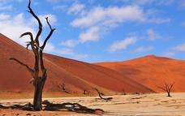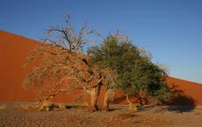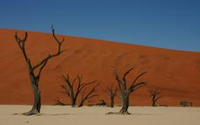

Dead Vlei
This ancient clay pan was once an oasis, studded with acacias and fed by a river that suddenly changed course, leaving the earth to dry up along with the trees it previously supported. So dry were the climatic conditions that the trees never decomposed – instead they were entirely leached of moisture so that today, 900 years later, they remain as desiccated, blackened sentinels dotting the pan’s cracked surface. Surrounded by the red-pink dunes of the Namibia Desert, they create a surreal spectacle that is a photographer's dream.
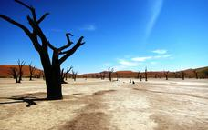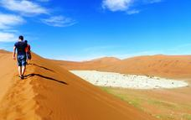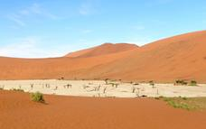

Dune 45
Named for its location 45 kilometres past the town of Sesriem, Dune 45 is renowned for its elegant shape, which – along with its position close to the road – have earned it the distinction of ‘most photographed dune in the world’. If you’re not keen for the strenuous hike to the top of Big Daddy, Dune 45 is a more forgiving alternative, standing at only 80 metres and featuring a much gentler gradient.
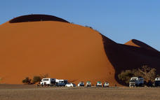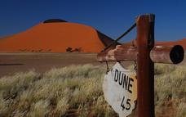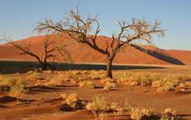

Sesriem Canyon
Sesriem Canyon is a captivating natural wonder located in the heart of the Namib Desert in Namibia. Carved over millions of years by the Tsauchab River, this narrow gorge is a testament to the power of erosion. The name Sesriem comes from the Afrikaans and Dutch words for six leather straps, which early pioneers used tied together to draw water from the deep pools within the canyon. Sesriem Canyon is not only a geological marvel but also a haven for unique desert flora and fauna, making it a popular stop for tourists exploring the surreal landscapes of the Namib Desert.

Basis
Full Board - Dinner, Bed, Breakfast and Lunch

Day 7: Naankuse @ Utopia, Windhoek

Day Itinerary
Sunday/Tuesday – Accommodation in Desert – Windhoek – 320 km
Our last day today but excitement is still on the menu. We head back to Solitaire where our guide will get us a sample of the apple pie that has made this homestead famous.
There is some lovely mountain scenery on our drive back to Windhoek. The road climbs up onto and over Namibia’s central plateau and we return to Windhoek via the small community at BűellsPort and the small town of Rehoboth. We arrive mid-afternoon and will be dropped at Chameleon Backpackers or the accommodation of our choice within Windhoek city limits.
Accommodation: None
Meals: Breakfast
For those that choose to fly today, NO FLIGHTS DEPARTING PRIOR TO 19H00 in case there are unexpected delays returning from safari.

Overnight: Naankuse @ Utopia View iBrochure
The modern N/a'ankusê@Utopia establishment has allied with the neighboring Pension Bougainvilla and offers serene rooms and luxurious suites situated amid beautiful, green lush gardens. The hotel is conveniently located in the tranquil suburb of Klein Windhoek.
Utopia combines business and leisure in a modest manner, simultaneously welcoming modern travelers and tourists in need of relaxation. Boasting 14 standard rooms, 7 luxurious suites and 1 executive suite, N/a'ankusê@Utopia creates an ideal hideaway.

Basis
Bed and Breakfast

Day 8: End of Itinerary

Day Itinerary
Monday/Wednesday - Departure from Windhoek
Today you will be transferred from your accommodation in Windhoek back to the International Airport for your departure flight.

